Administering Microsoft Azure SQL Solutions. Part4

Contents

LP6. Automate database tasks for Azure SQL 3

M1. Automate deployment of database resources 3

U1. Introduction 3

U2. Describe deployment models in Azure 4

U3. Automate deployment by using Azure Resource Manager templates and Bicep 6

U4. Automate deployment by using PowerShell 16

U5. Automate deployment by using Azure CLI 18

U6. Knowledge check 21

M2. Create and manage SQL Agent jobs 22

U1. Introduction 22

U2. Create a SQL Server maintenance plan 23

U3. Describe task status notifications 30

U4. Knowledge check 33

M3. Manage Azure PaaS tasks using automation 34

U1. Introduction 34

U2. Explore Elastic jobs 35

U3. Understand Azure Automation 38

U4. Build an automation runbook 41

U5. Automate database workflows by using Logic Apps 47

U6. Monitor automated tasks 53

U7. Knowledge check 60

LP7. Plan and implement a high availability and disaster recovery environment 61

M1. Describe high availability and disaster recovery strategies 61

U1. Introduction 61

U2. Describe recovery time objective and recovery point objective 62

U3. Explore high availability and disaster recovery options 63

U4. Describe Azure high availability and disaster recovery features for Azure Virtual Machines 67

U5. Describe high availability and disaster recovery options for PaaS deployments 69

U6. Explore an IaaS high availability and disaster recovery solution 70

U7. Describe hybrid solutions 75

U8. Knowledge check 76

M2. Explore IaaS and PaaS solutions for high availability and disaster recovery 77

U1. Introduction 77

U2. Describe failover clusters in Windows Server 78

U3. Configure Always-on availability groups 83

U4. Describe temporal tables in Azure SQL Database 87

U5. Describe active geo-replication for Azure SQL Database 88

U6. Explore auto-failover groups for Azure SQL Database and Azure SQL Managed Instance 90

U7. Knowledge check 92

M3. Back up and restore databases 93

U1. Introduction 93

# LP6. Automate database tasks for Azure SQL

## M1. Automate deployment of database resources

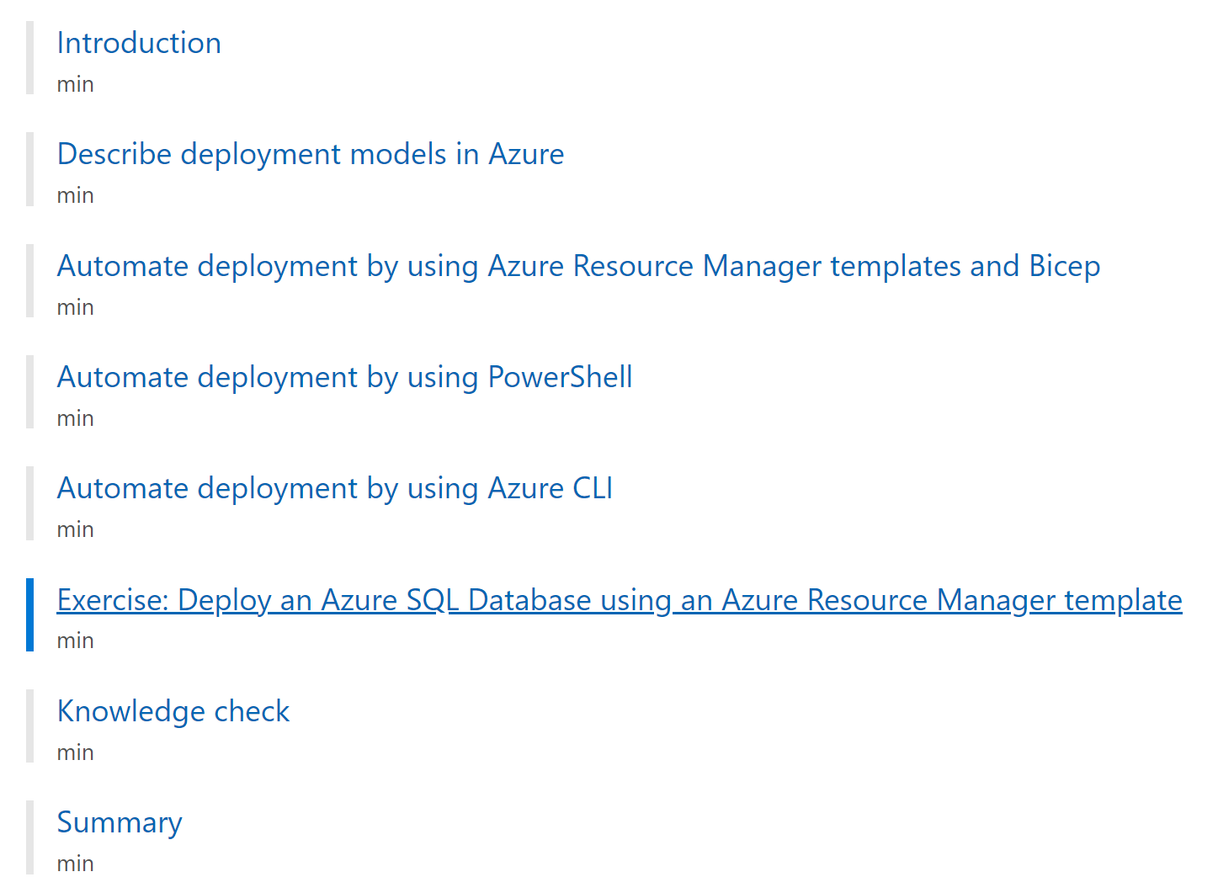

### U1. Introduction

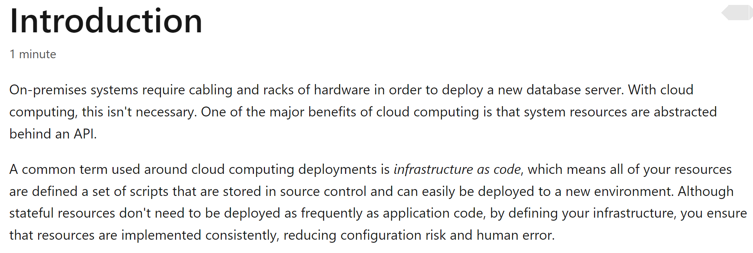

### U2. Describe deployment models in Azure

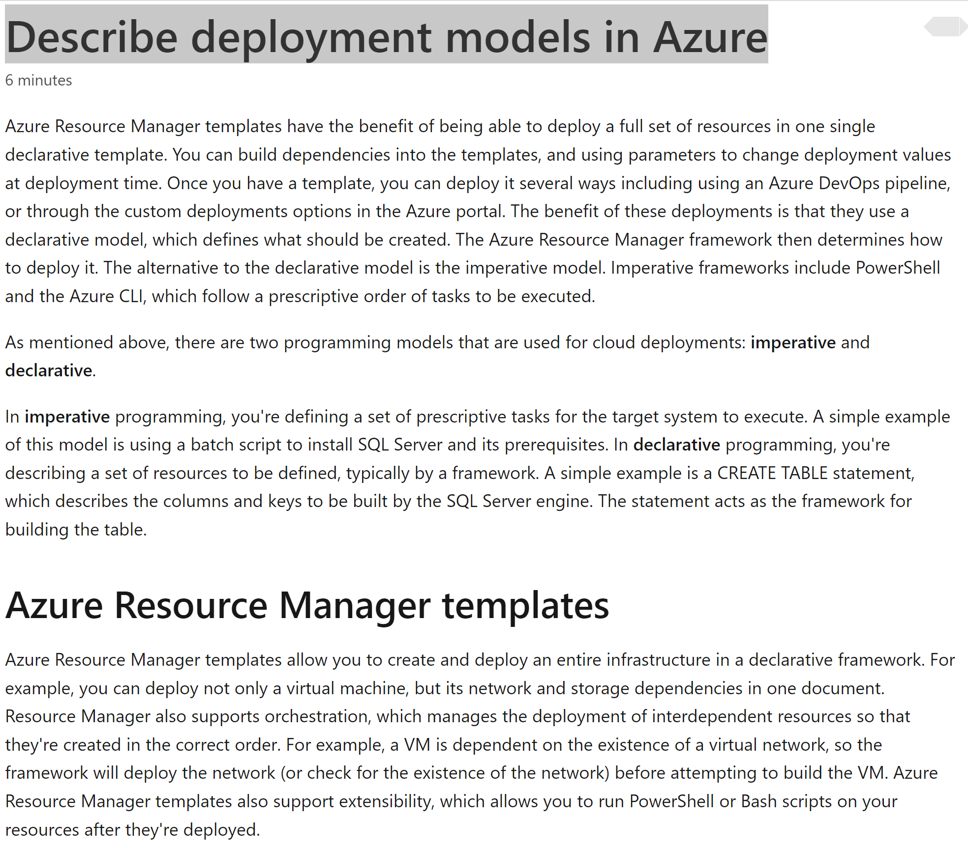

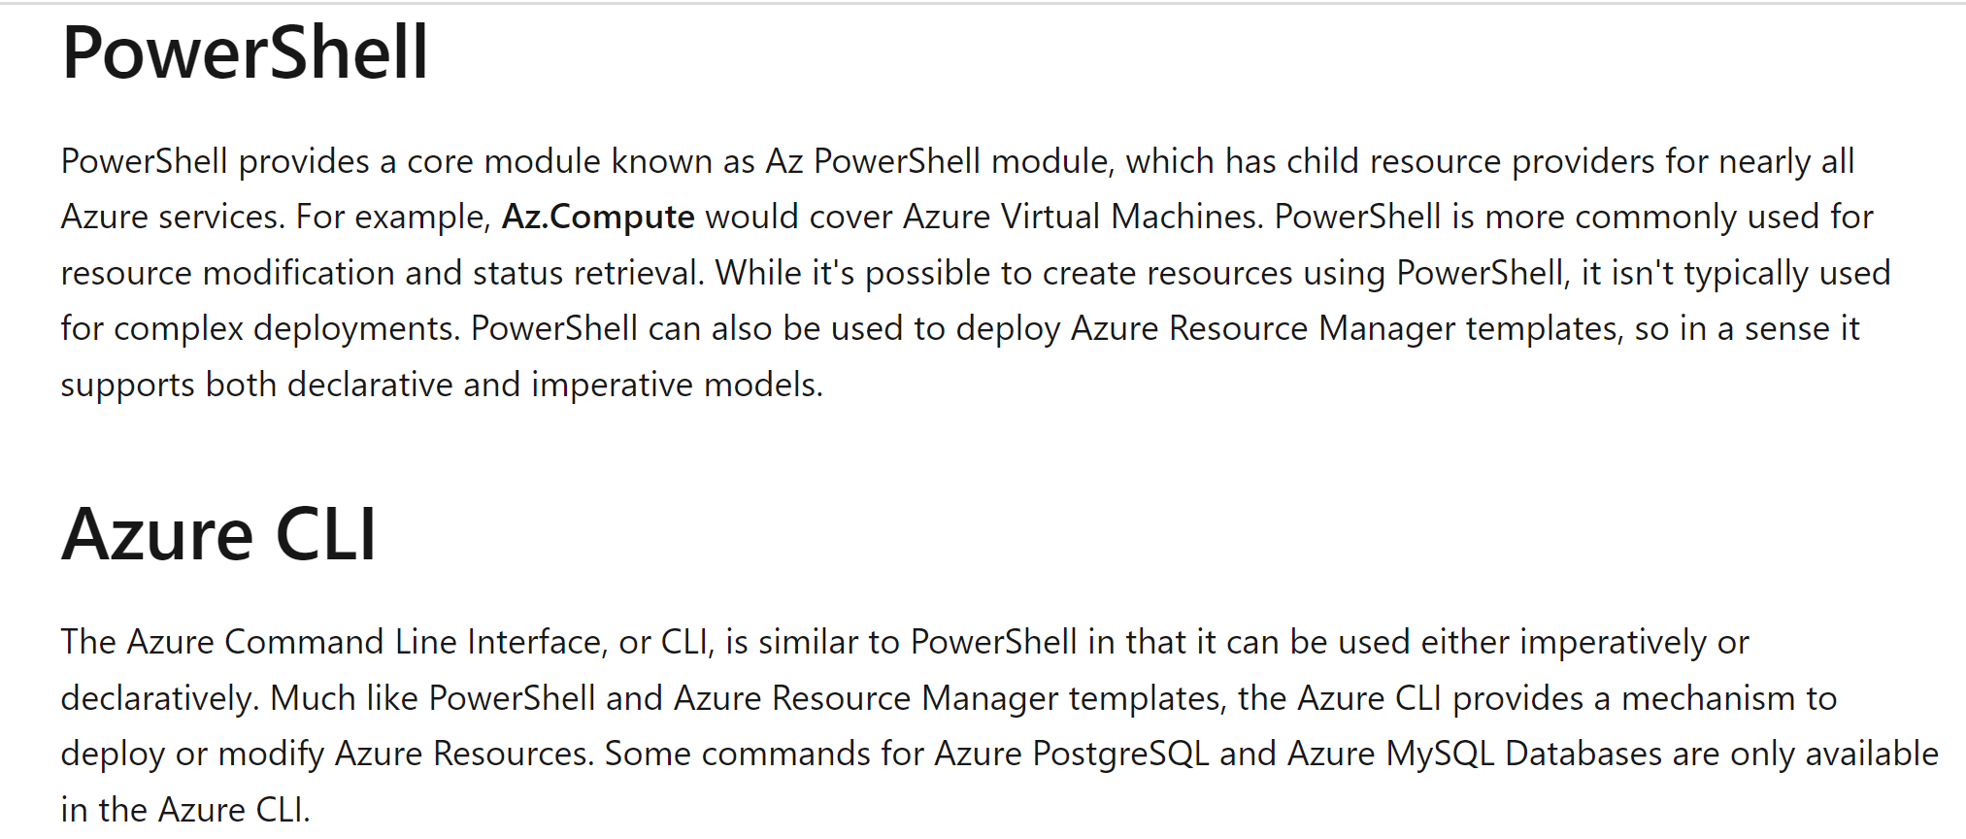

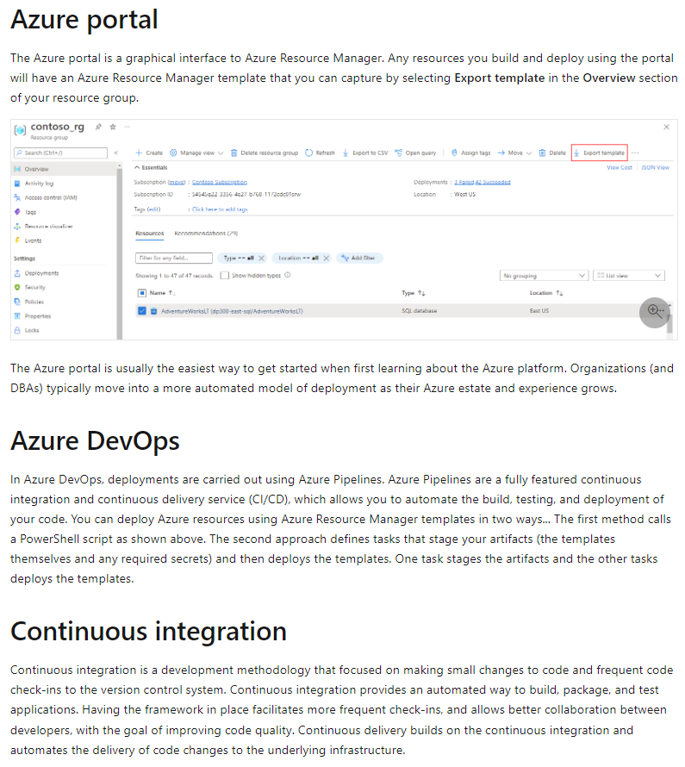

### U3. Automate deployment by using Azure Resource Manager templates and Bicep

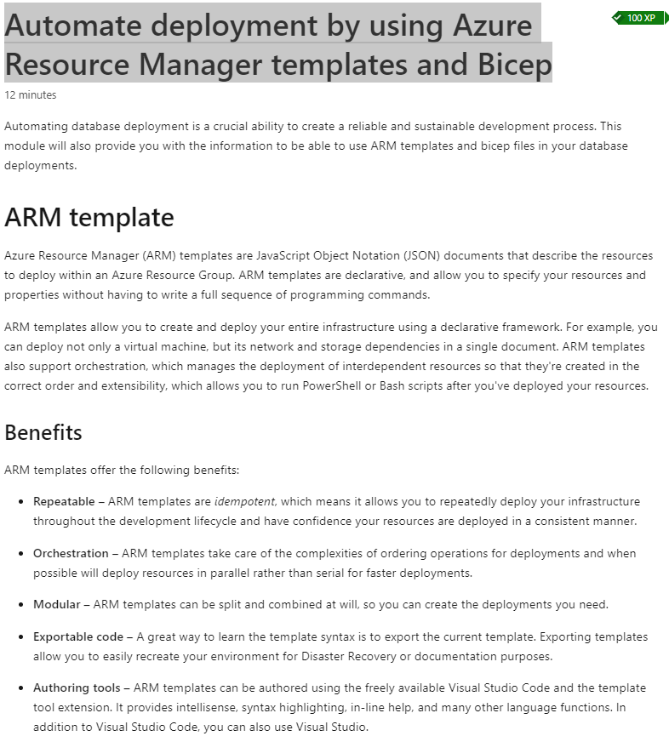

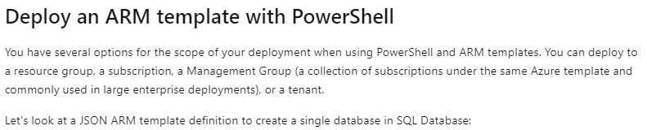

{

"$schema": "https://schema.management.azure.com/schemas/2019-04-01/deploymentTemplate.json#",

"contentVersion": "1.0.0.0",

"metadata": {

"_generator": {

"name": "bicep",

"version": "0.5.6.12127",

"templateHash": "17606057535442789180"

}

},

"parameters": {

"serverName": {

"type": "string",

"defaultValue": "[uniqueString('sql', resourceGroup().id)]",

"metadata": {

"description": "The name of the SQL logical server."

}

},

"sqlDBName": {

"type": "string",

"defaultValue": "SampleDB",

"metadata": {

"description": "The name of the SQL Database."

}

},

"location": {

"type": "string",

"defaultValue": "[resourceGroup().location]",

"metadata": {

"description": "Location for all resources."

}

},

"administratorLogin": {

"type": "string",

"metadata": {

"description": "The administrator username of the SQL logical server."

}

},

"administratorLoginPassword": {

"type": "secureString",

"metadata": {

"description": "The administrator password of the SQL logical server."

}

}

},

"resources": [

{

"type": "Microsoft.Sql/servers",

"apiVersion": "2021-08-01-preview",

"name": "[parameters('serverName')]",

"location": "[parameters('location')]",

"properties": {

"administratorLogin": "[parameters('administratorLogin')]",

"administratorLoginPassword": "[parameters('administratorLoginPassword')]"

}

},

{

"type": "Microsoft.Sql/servers/databases",

"apiVersion": "2021-08-01-preview",

"name": "[format('{0}/{1}', parameters('serverName'), parameters('sqlDBName'))]",

"location": "[parameters('location')]",

"sku": {

"name": "Standard",

"tier": "Standard"

},

"dependsOn": [

"[resourceId('Microsoft.Sql/servers', parameters('serverName'))]"

]

}

]

}

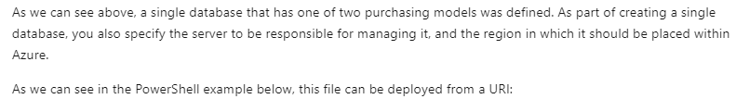

$projectName = Read-Host -Prompt "Enter a project name that is used for generating resource names"

$location = Read-Host -Prompt "Enter an Azure location (i.e. centralus)"

$adminUser = Read-Host -Prompt "Enter the SQL server administrator username"

$adminPassword = Read-Host -Prompt "Enter the SQL server administrator password" -AsSecureString

$resourceGroupName = "${projectName}rg"

New-AzResourceGroup -Name $resourceGroupName -Location $location

New-AzResourceGroupDeployment -ResourceGroupName $resourceGroupName -TemplateUri "https://raw.githubusercontent.com/Azure/azure-quickstart-templates/master/quickstarts/microsoft.sql/sql-database/azuredeploy.json" -administratorLogin $adminUser -administratorLoginPassword $adminPassword

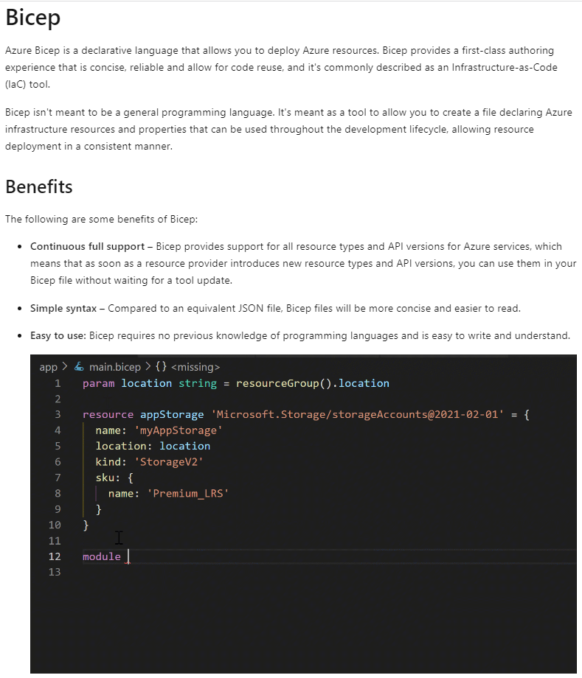



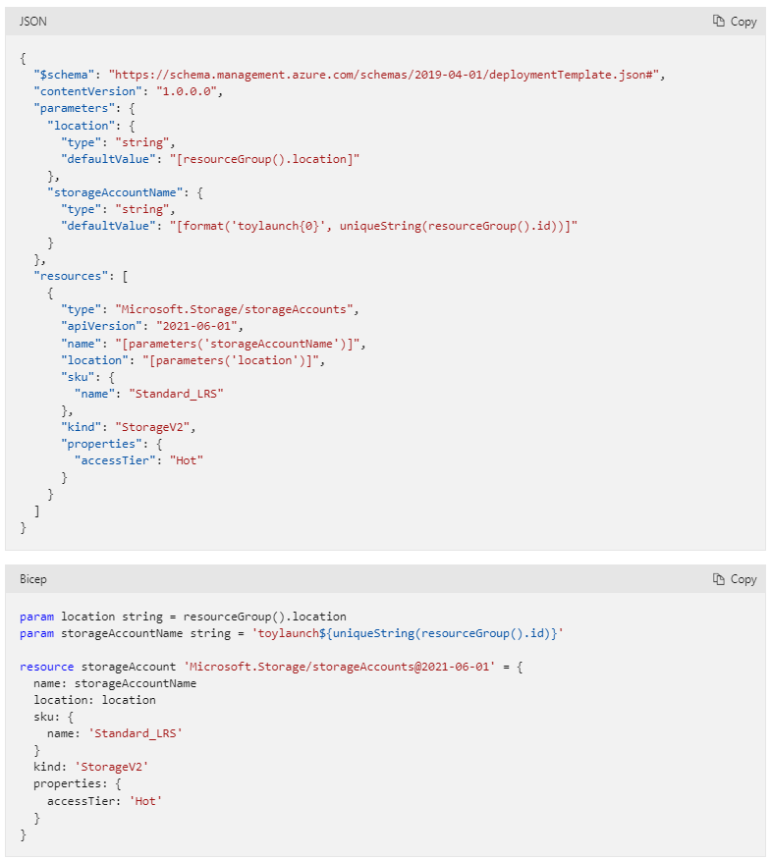

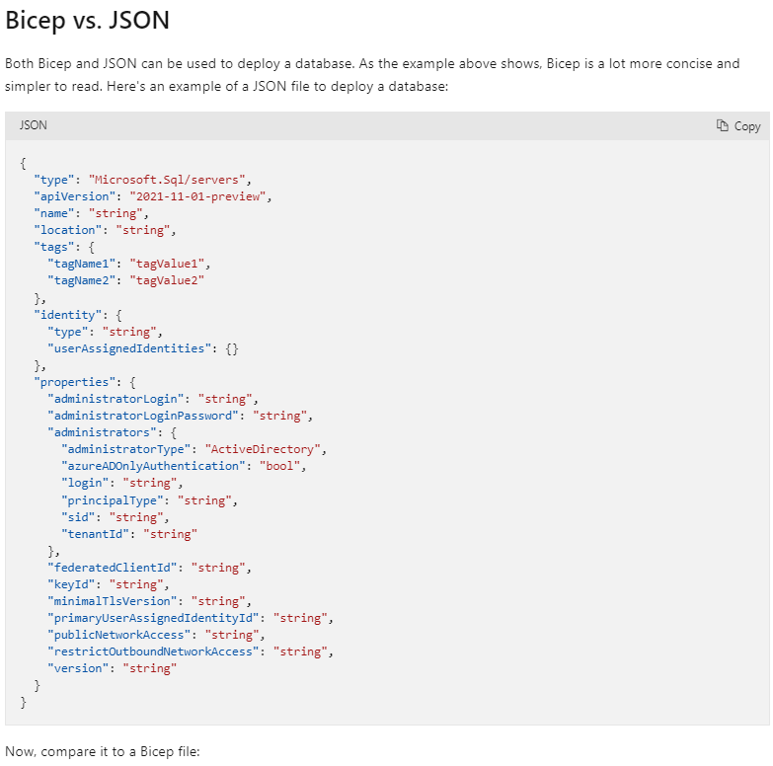

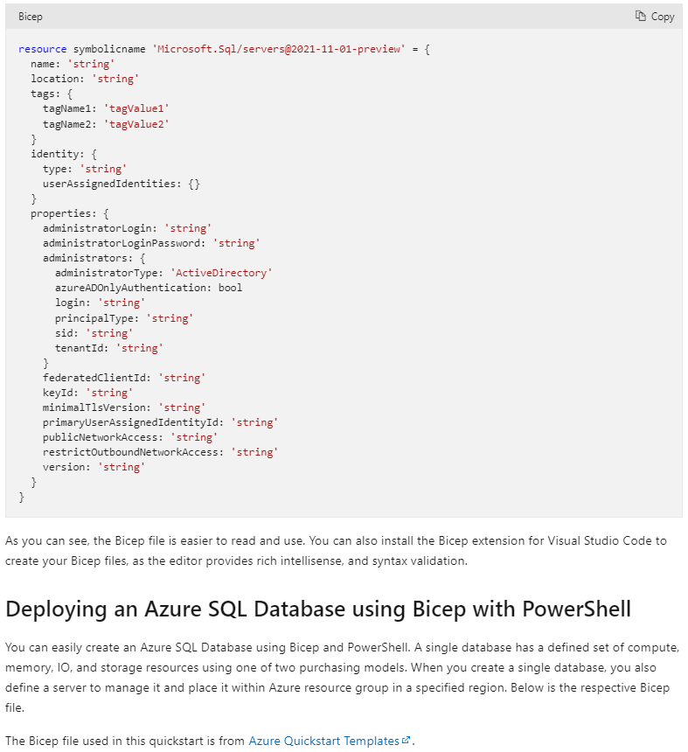

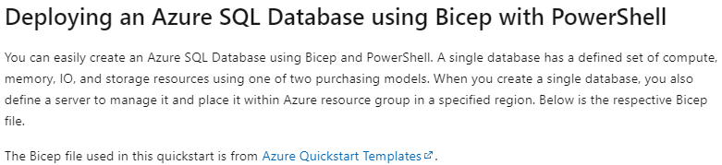

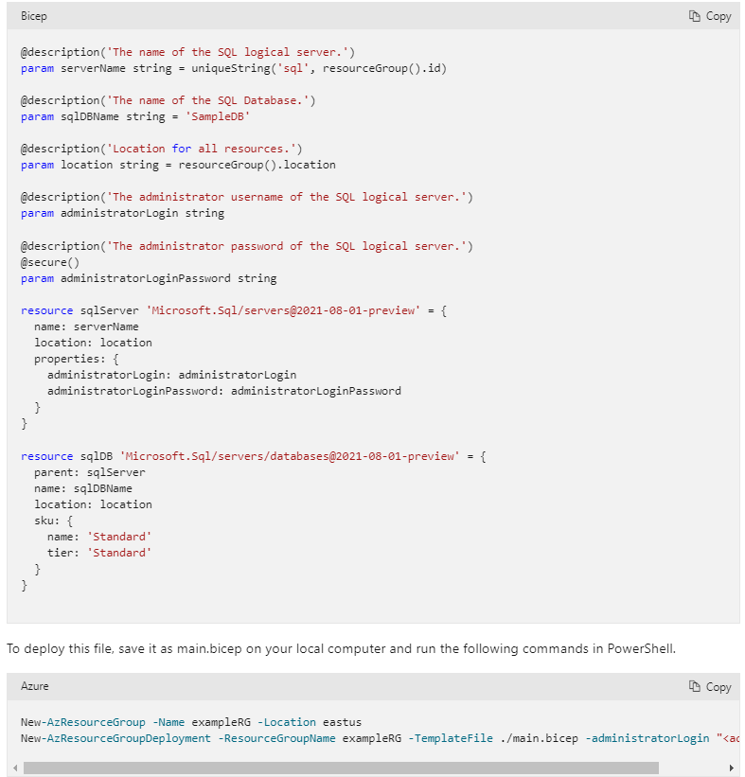

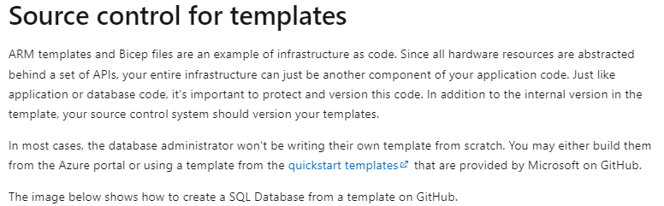

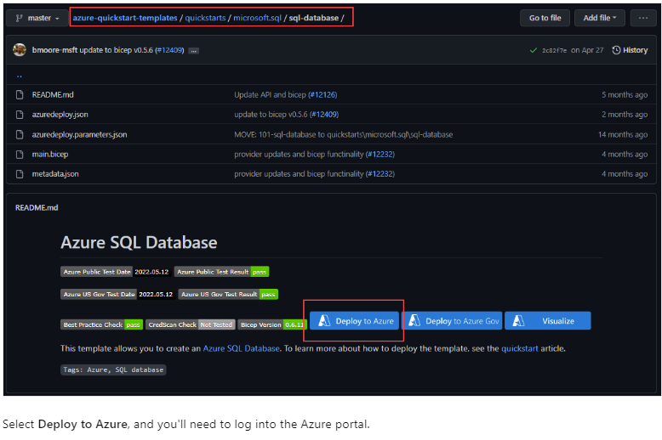

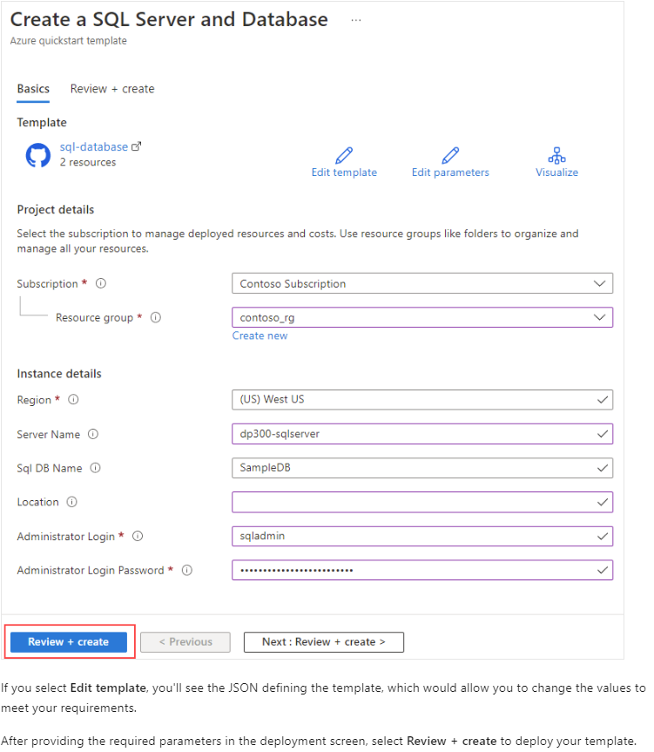

### U4. Automate deployment by using PowerShell

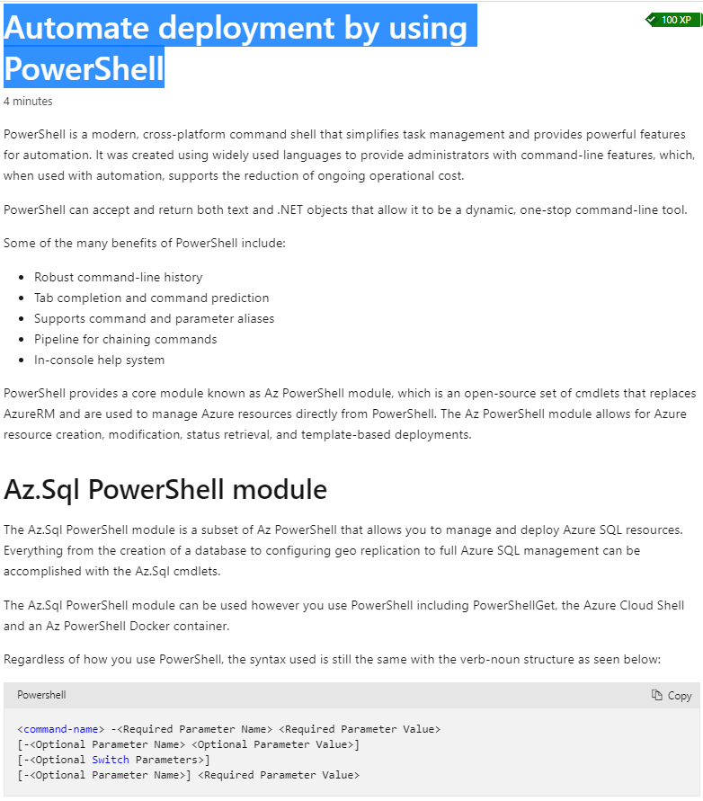

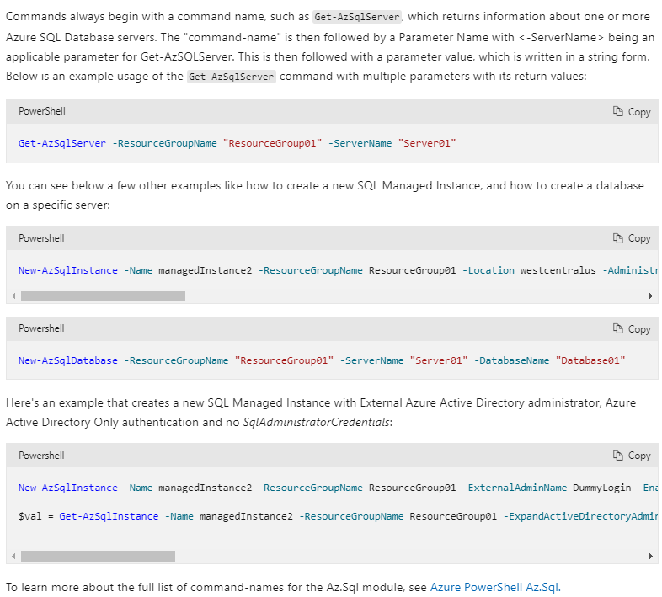

### U5. Automate deployment by using Azure CLI

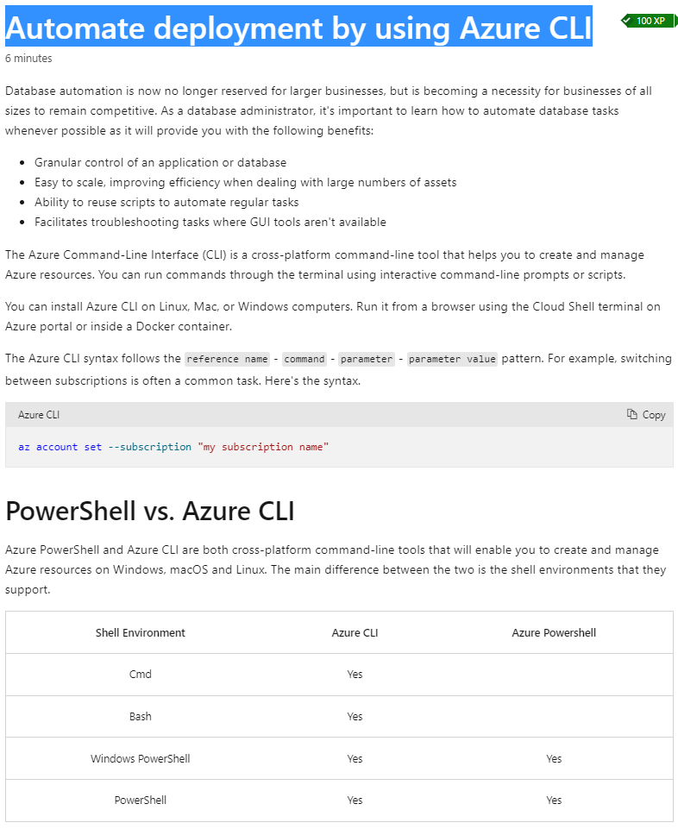

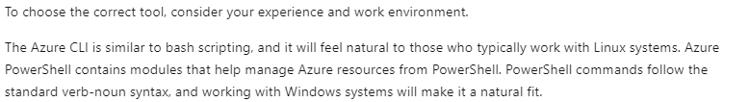

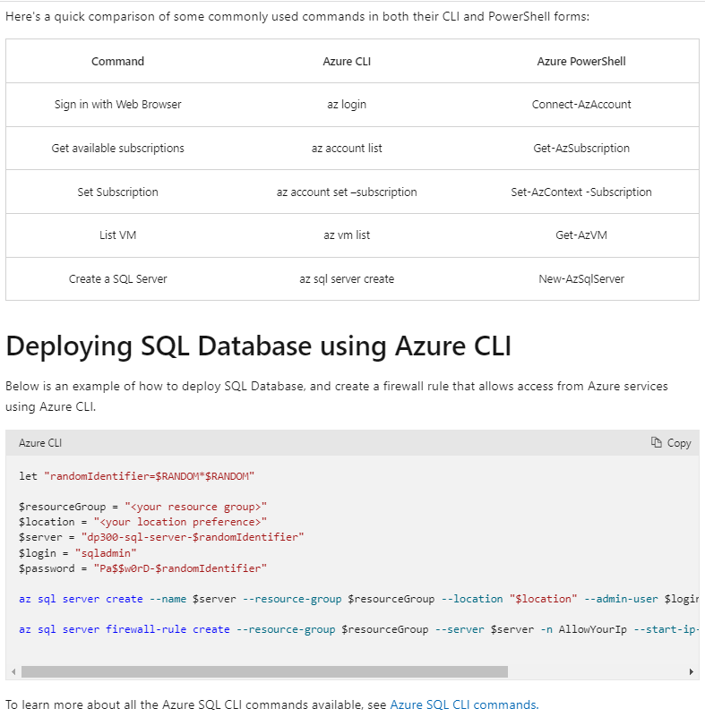

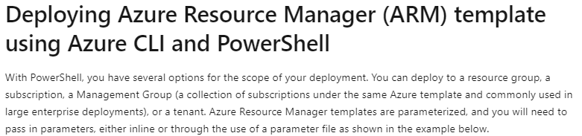

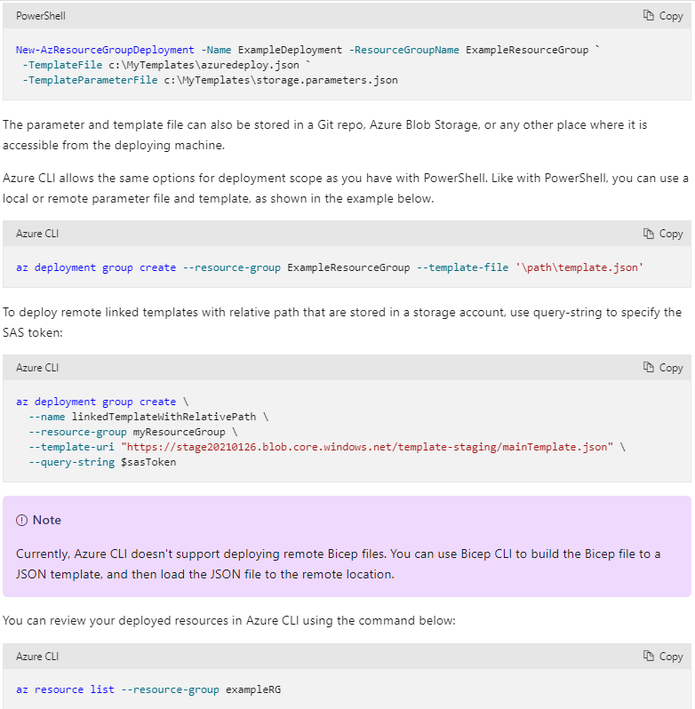

### U6. Knowledge check

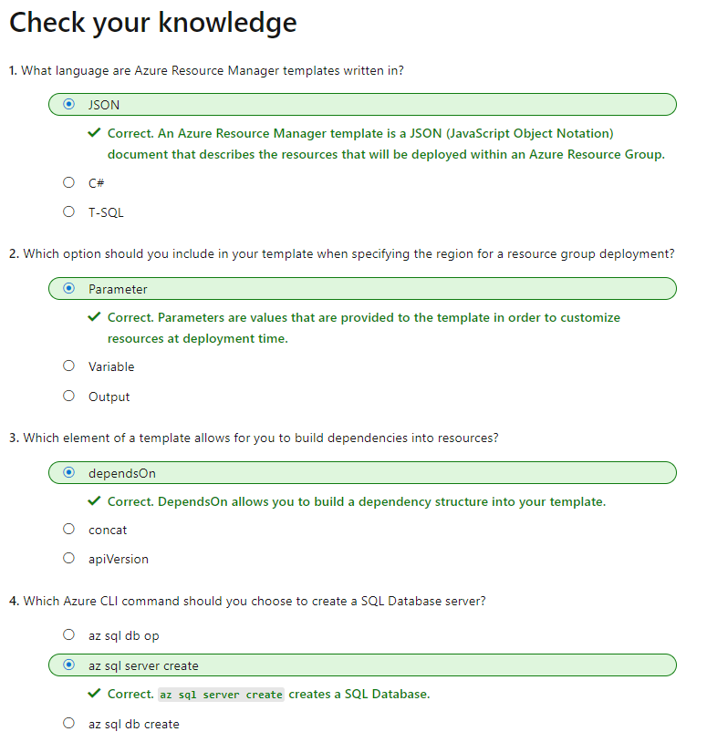

## M2. Create and manage SQL Agent jobs

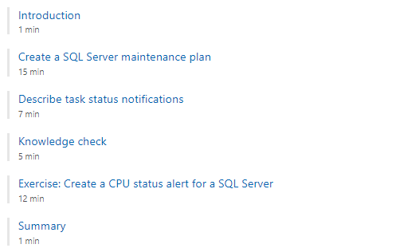

### U1. Introduction

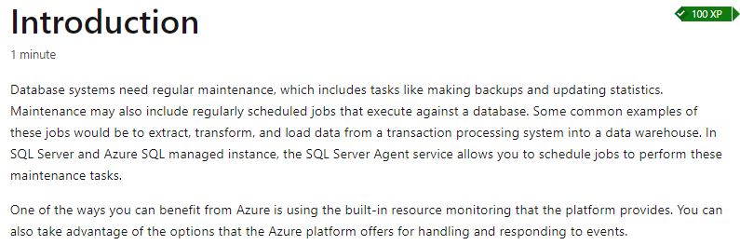

### U2. Create a SQL Server maintenance plan

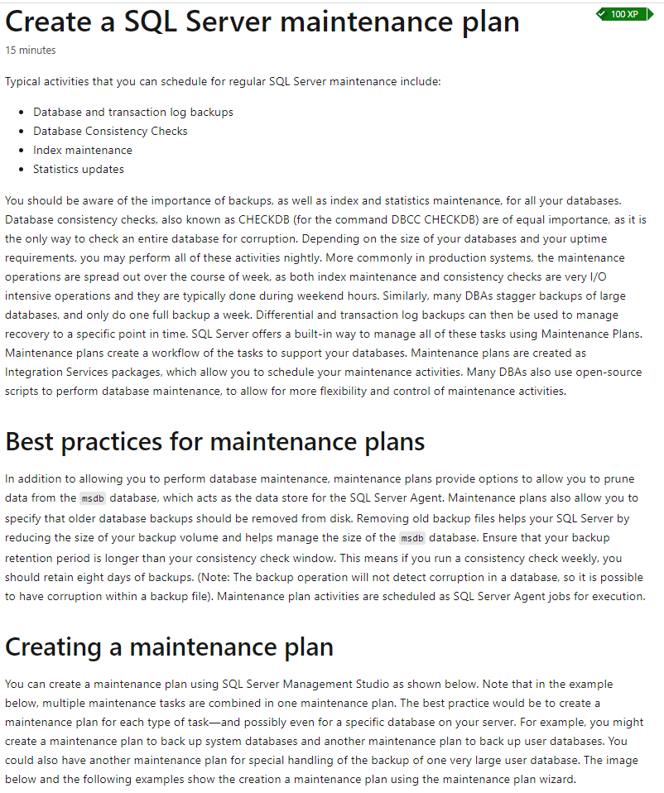

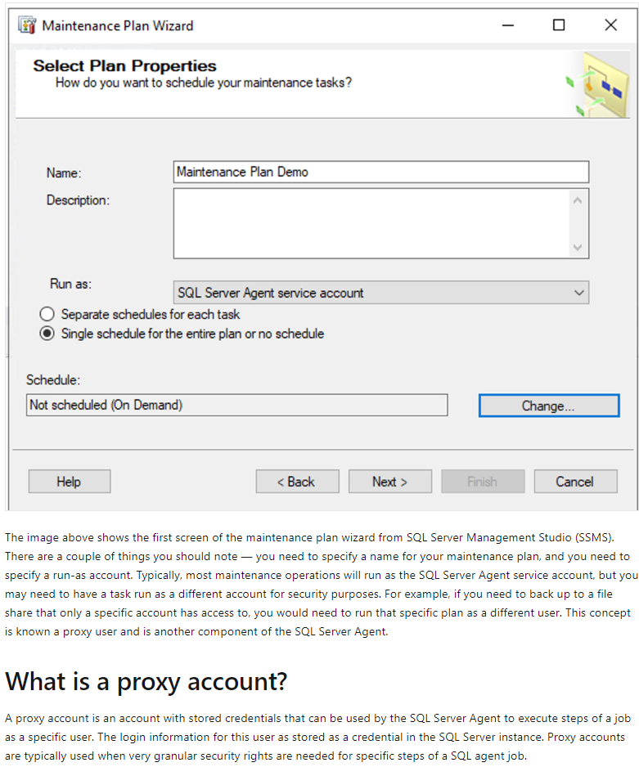

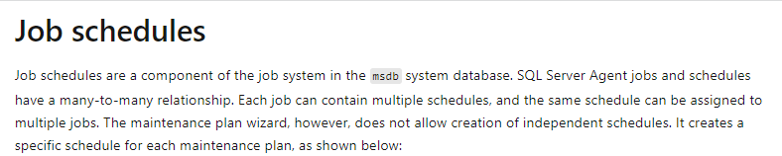

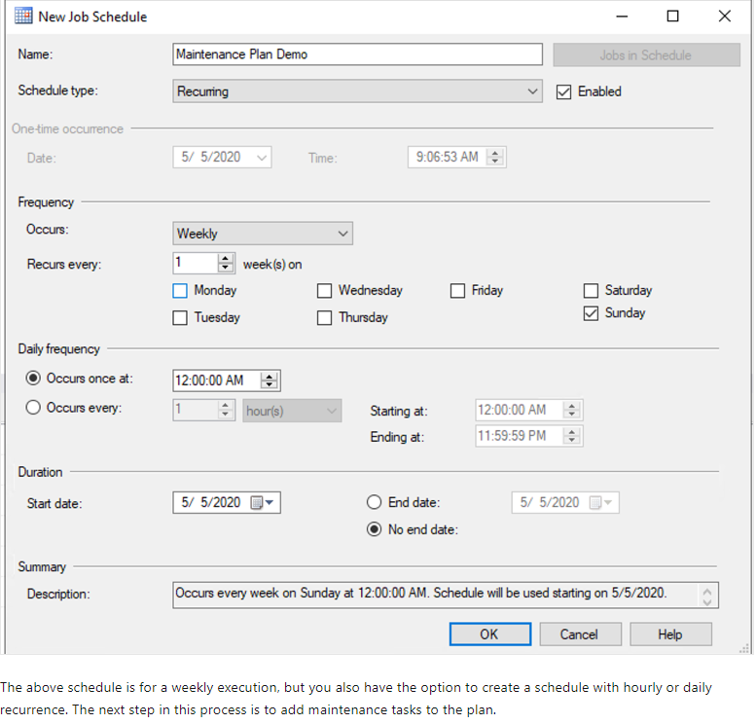

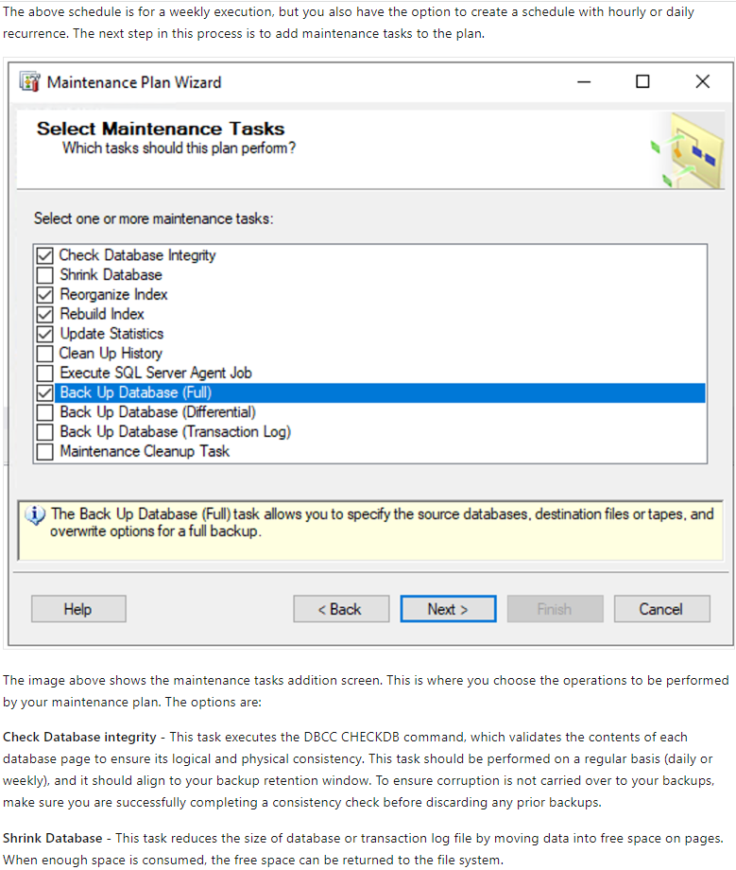

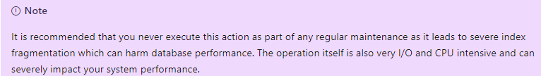

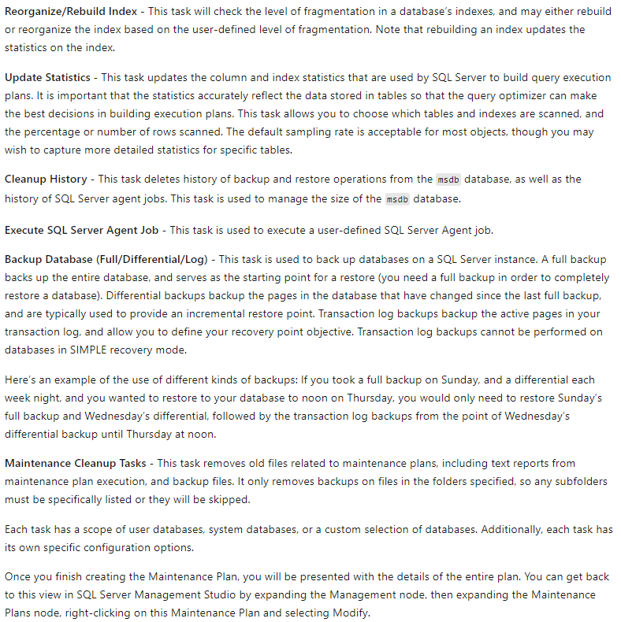

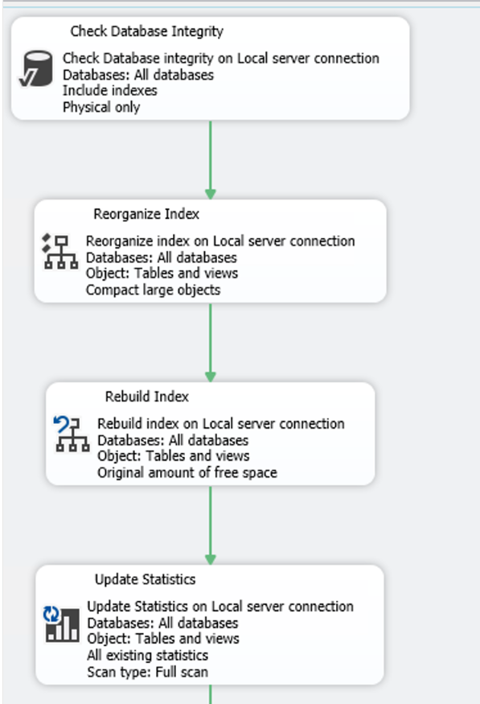

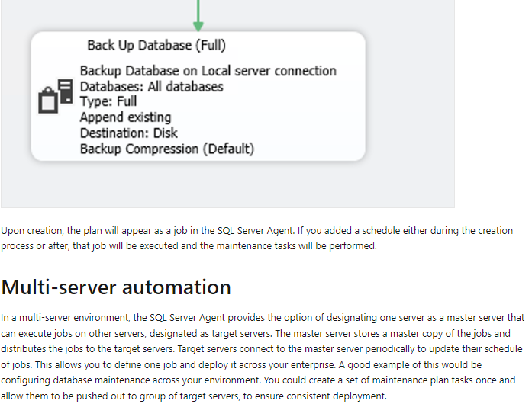

### U3. Describe task status notifications

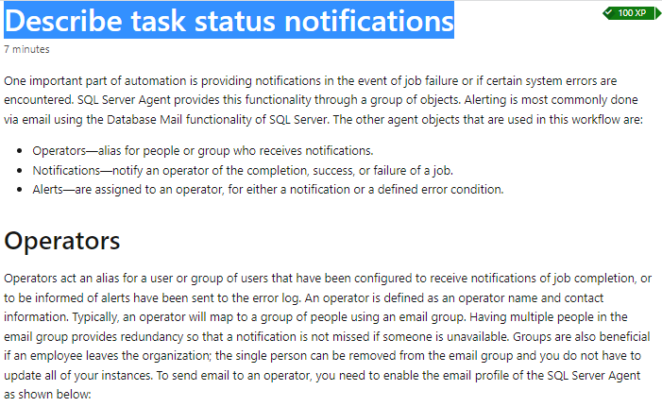

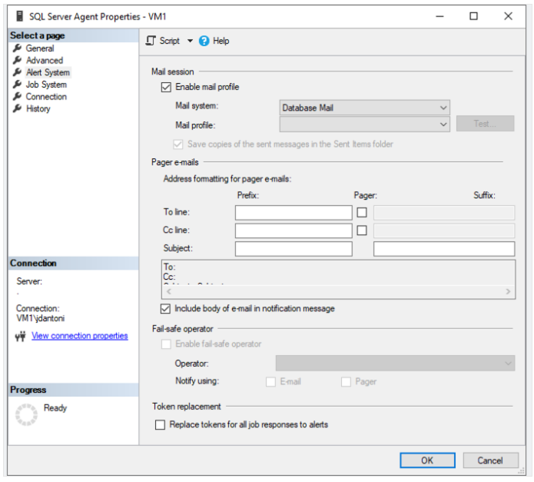

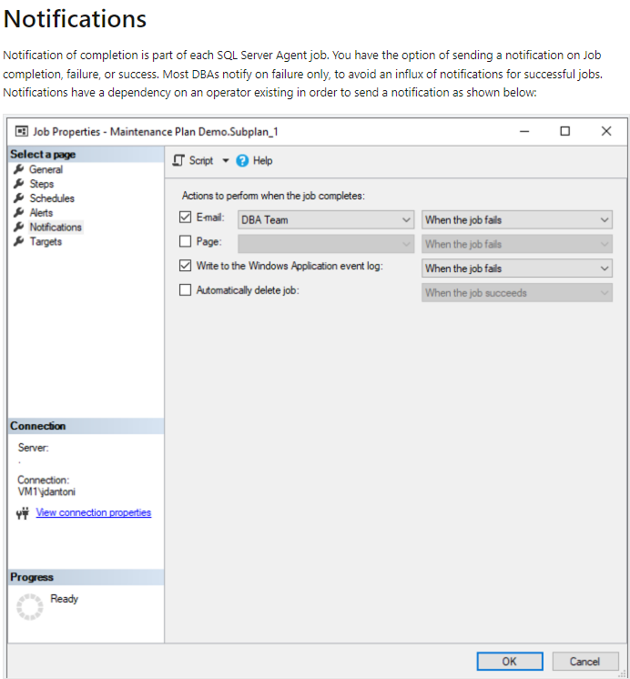

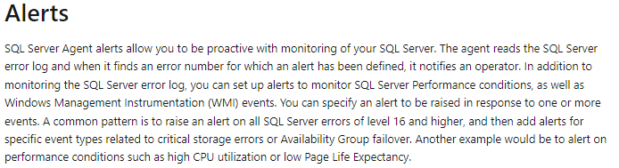

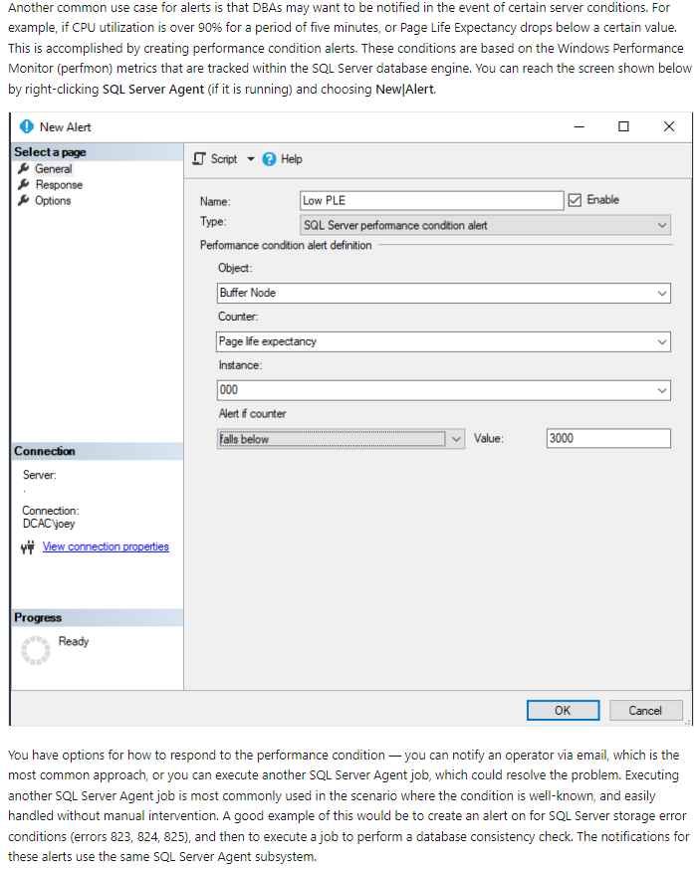

### U4. Knowledge check

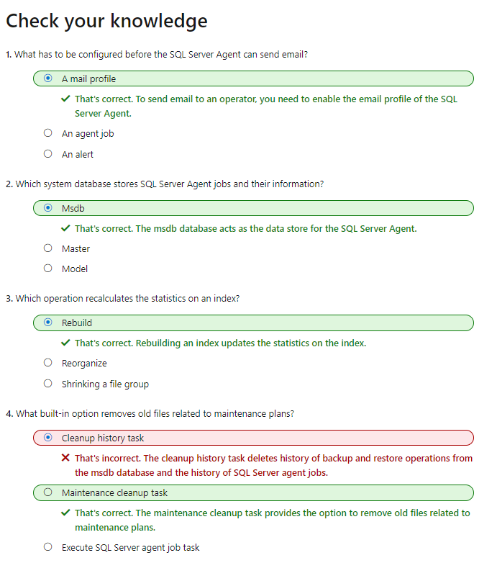

## M3. Manage Azure PaaS tasks using automation

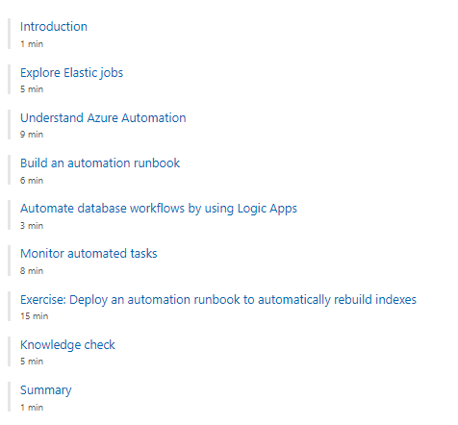

### U1. Introduction

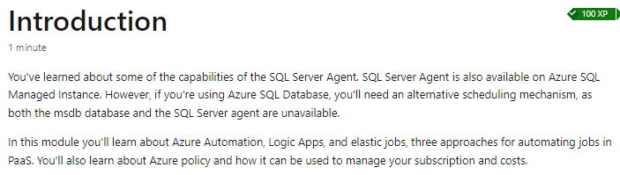

### U2. Explore Elastic jobs

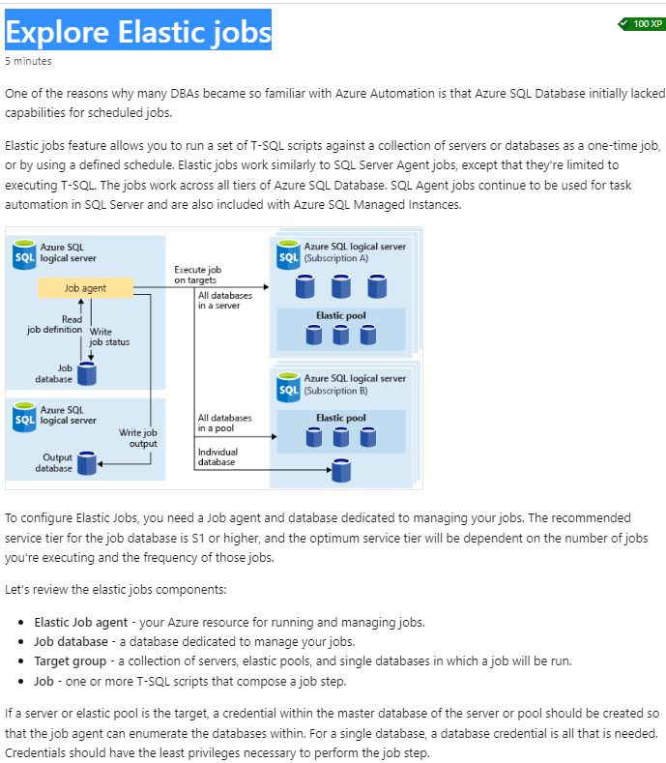

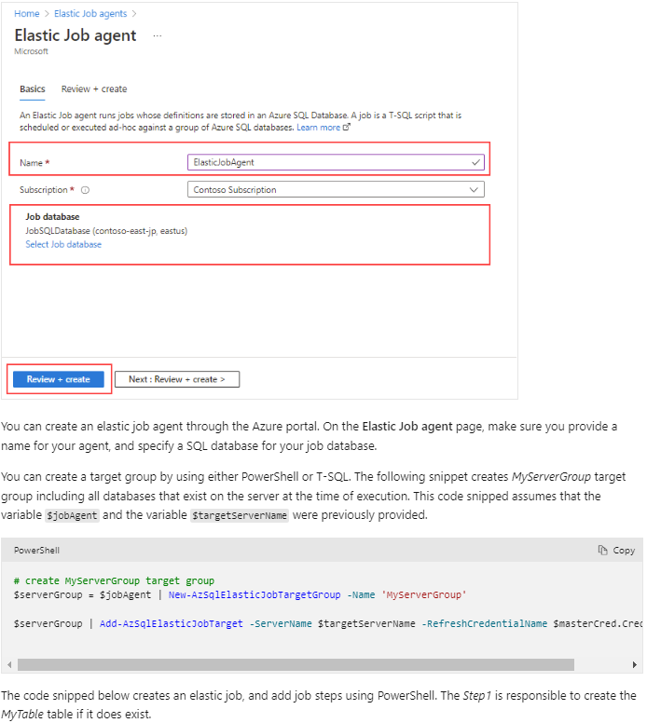

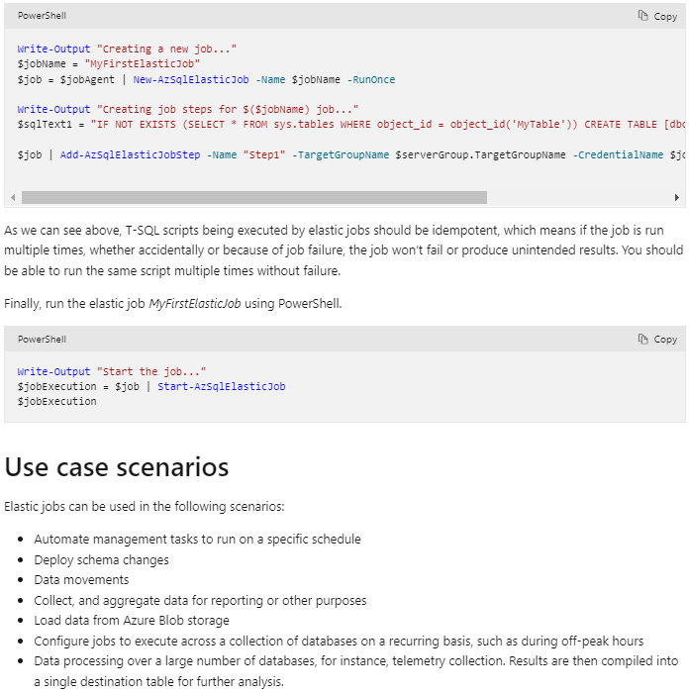

### U3. Understand Azure Automation

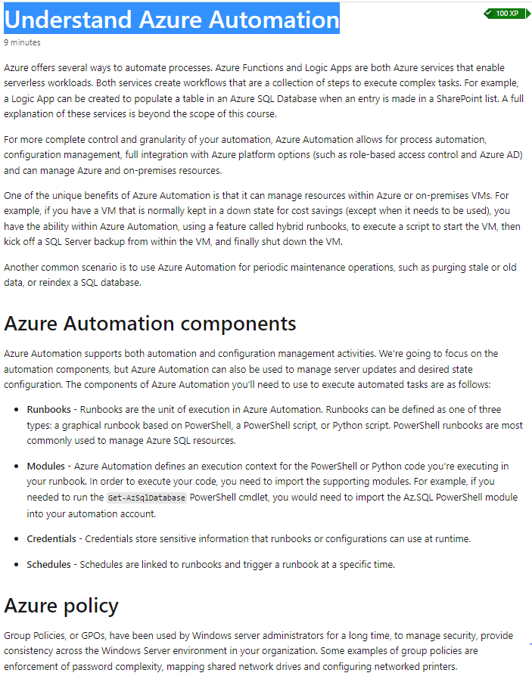

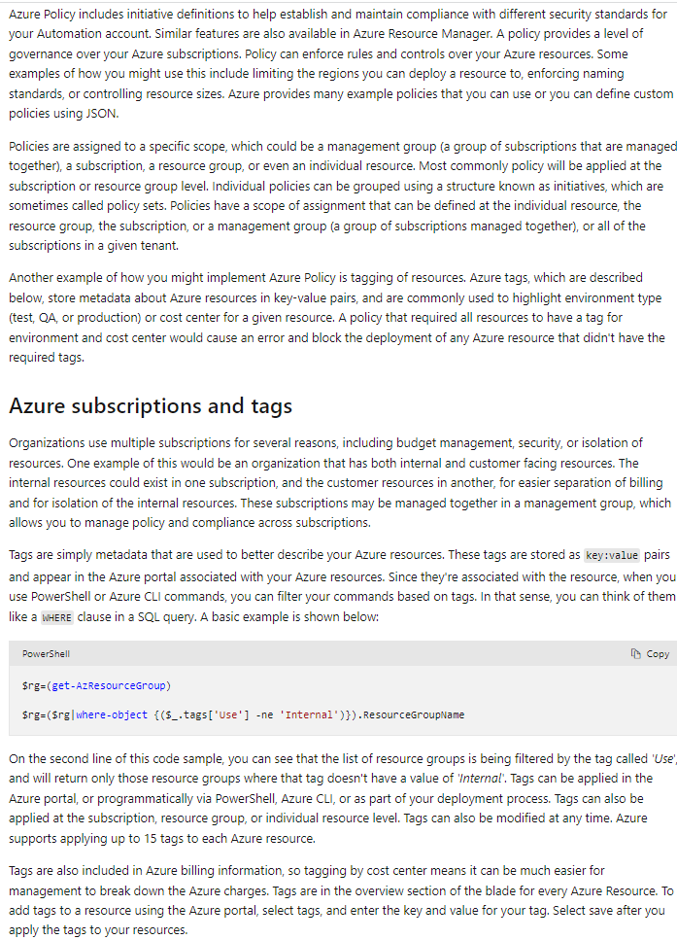

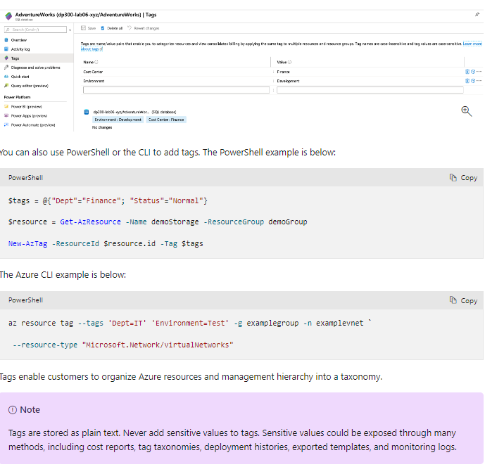

### U4. Build an automation runbook

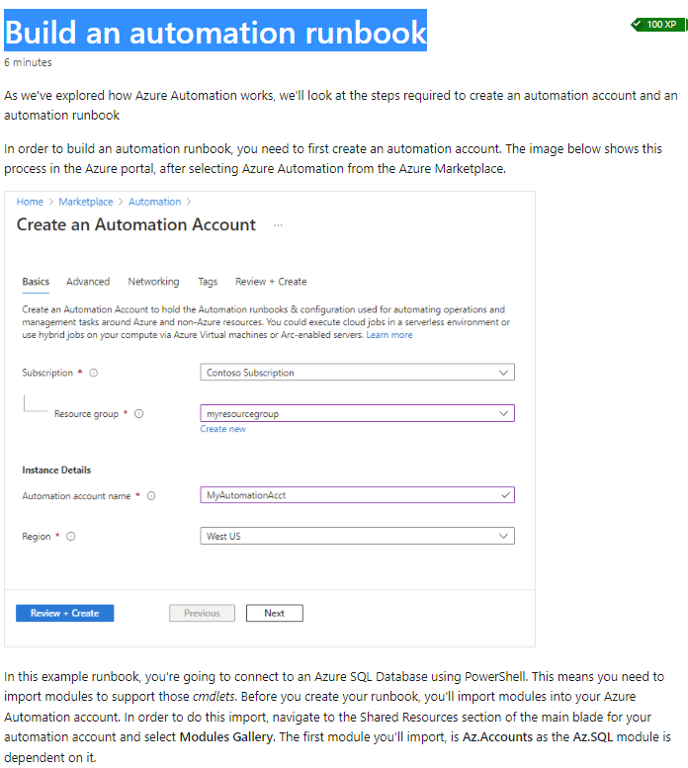

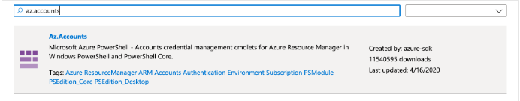

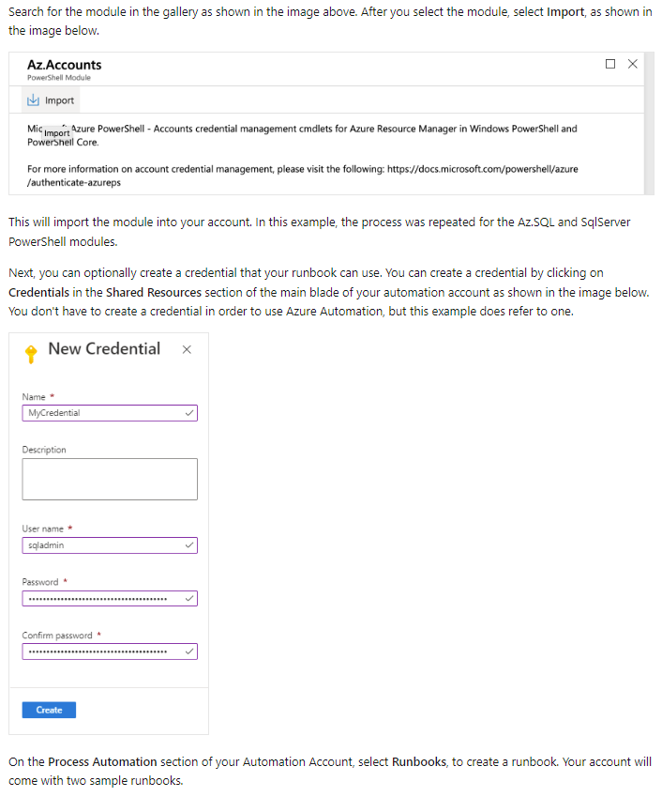

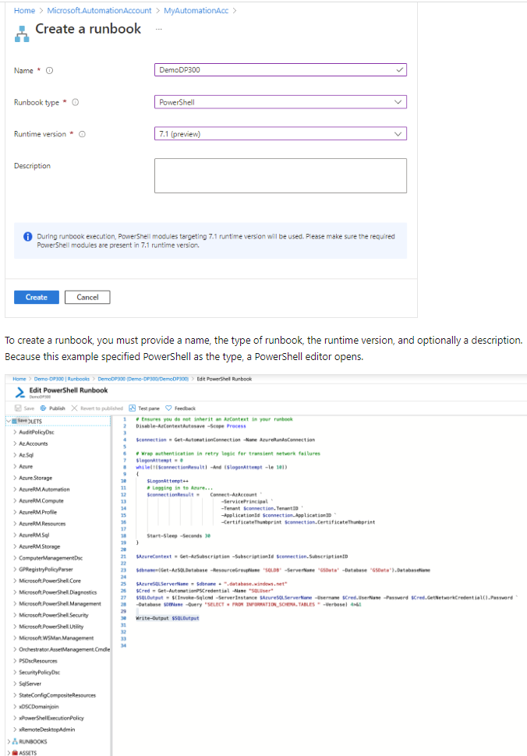

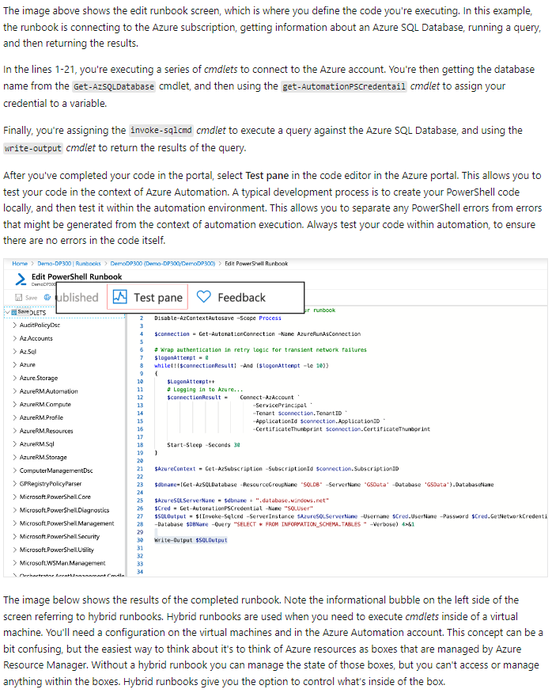

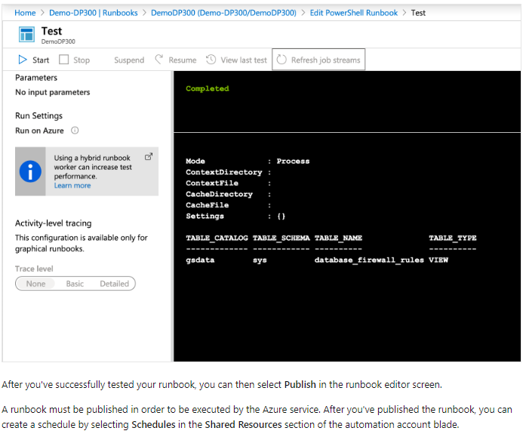

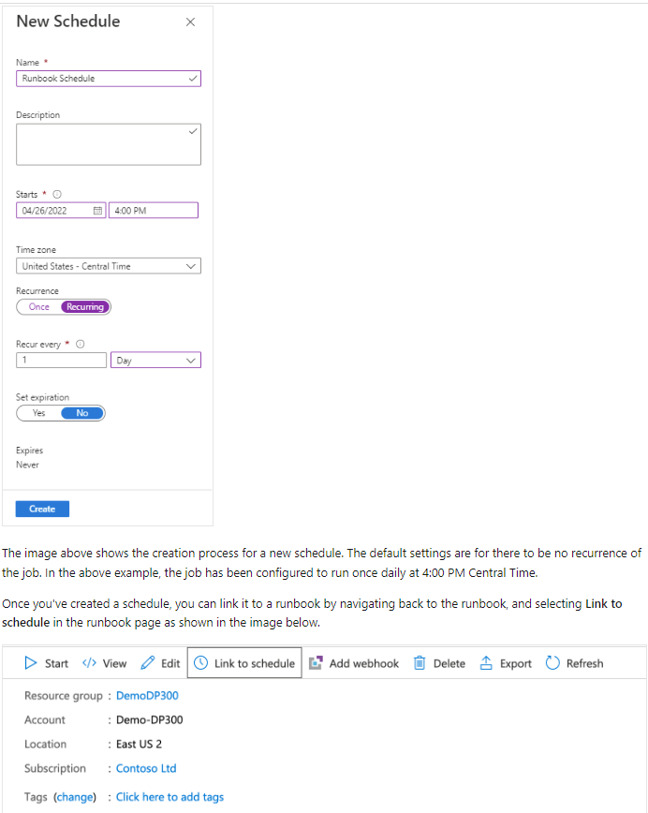

### U5. Automate database workflows by using Logic Apps

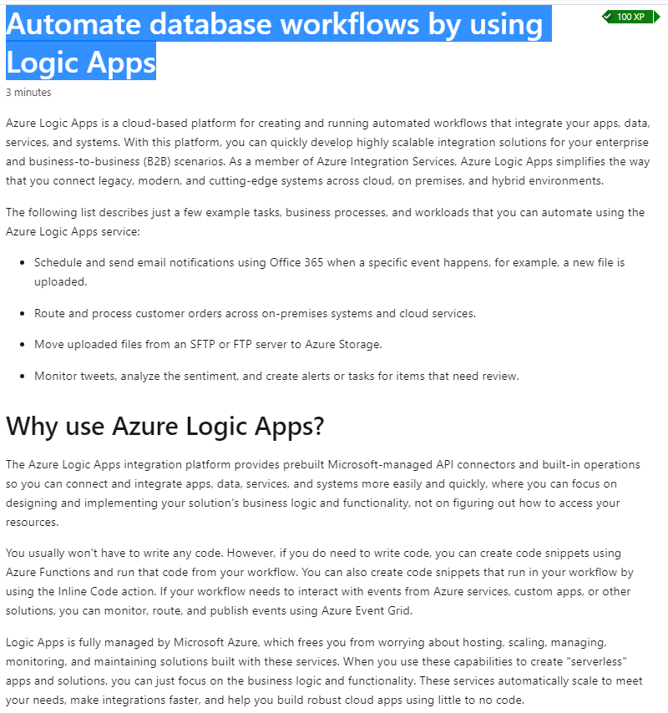

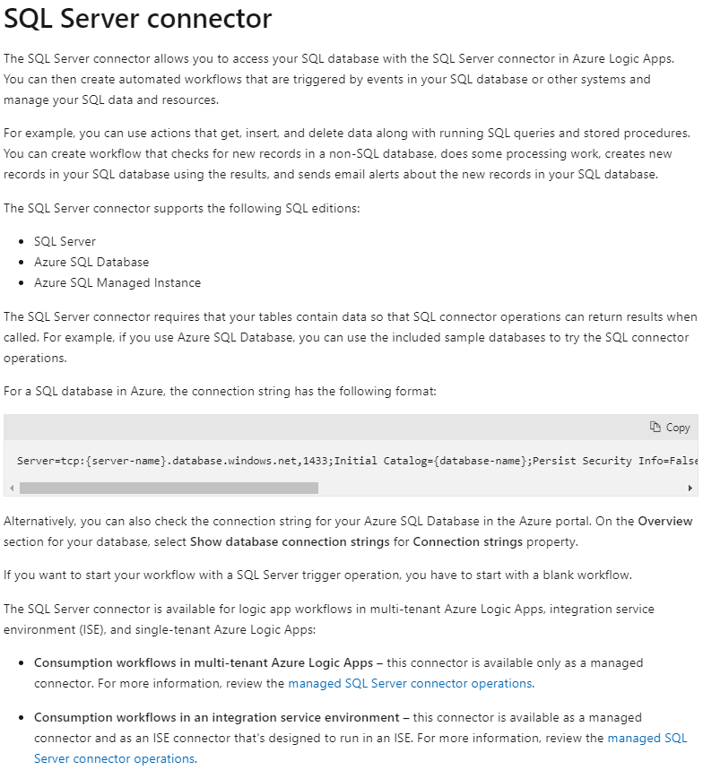

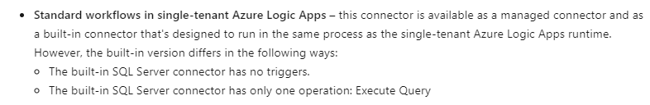

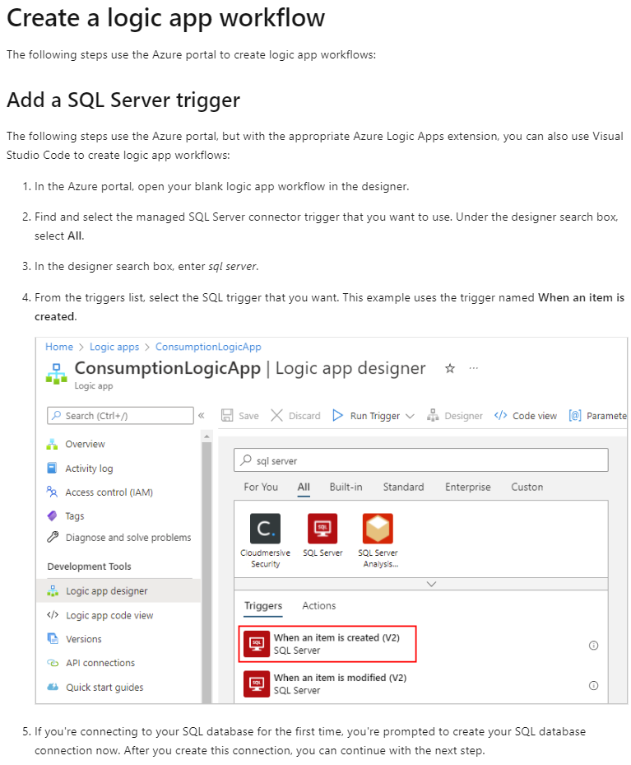

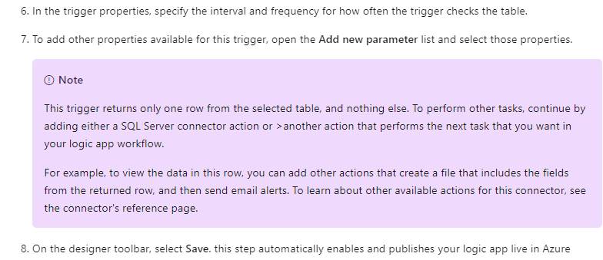

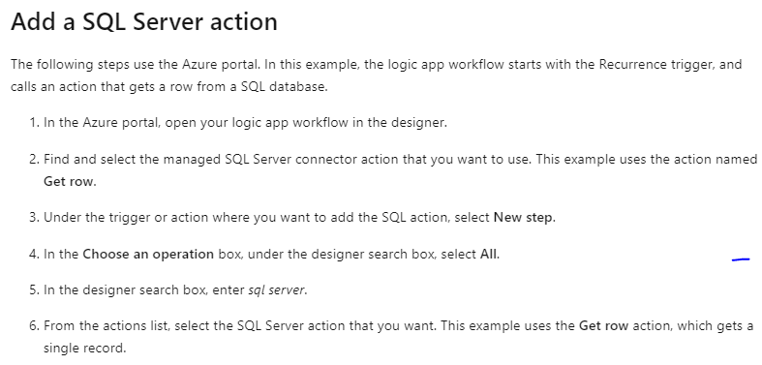

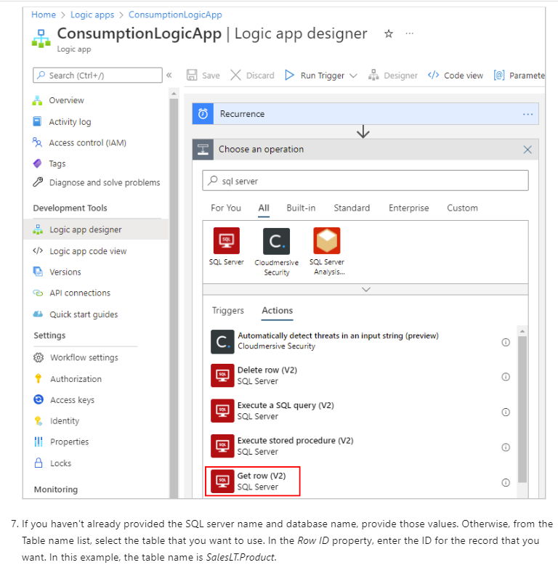

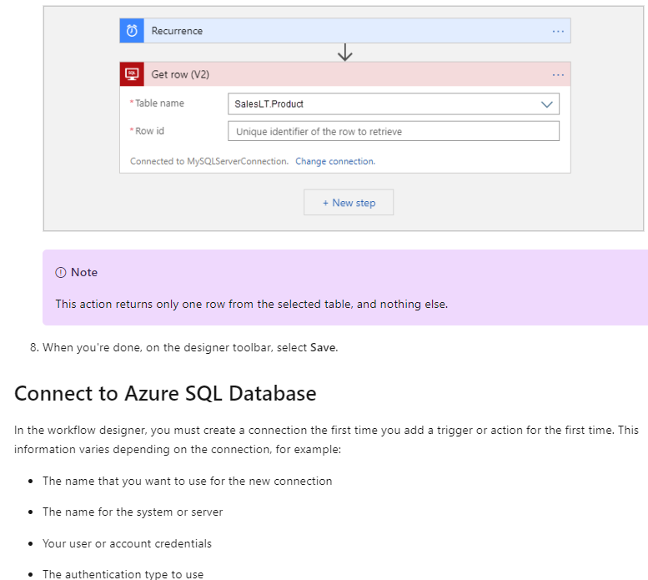

### U6. Monitor automated tasks

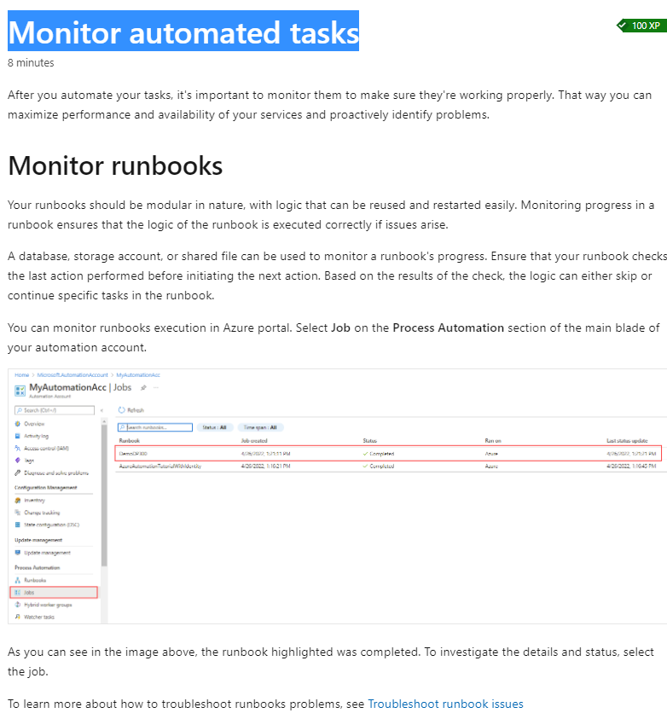

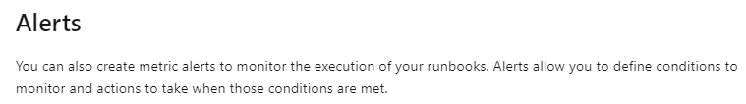

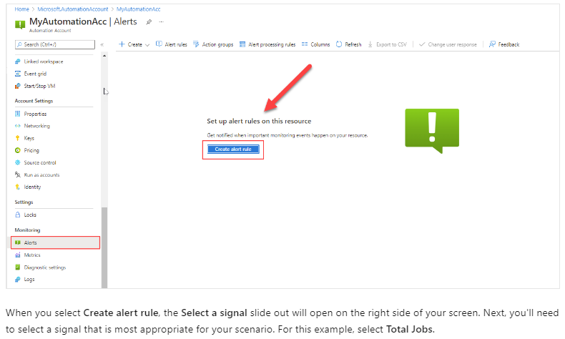

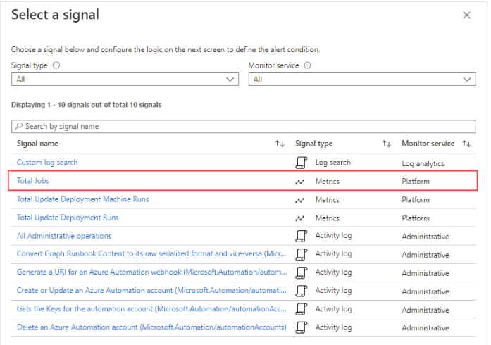

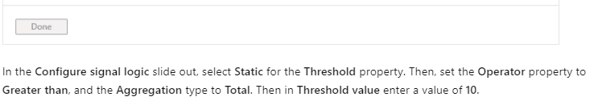

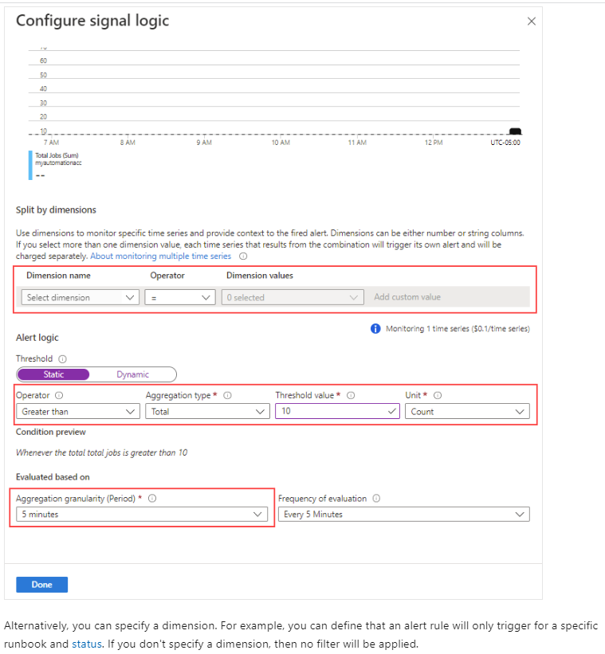

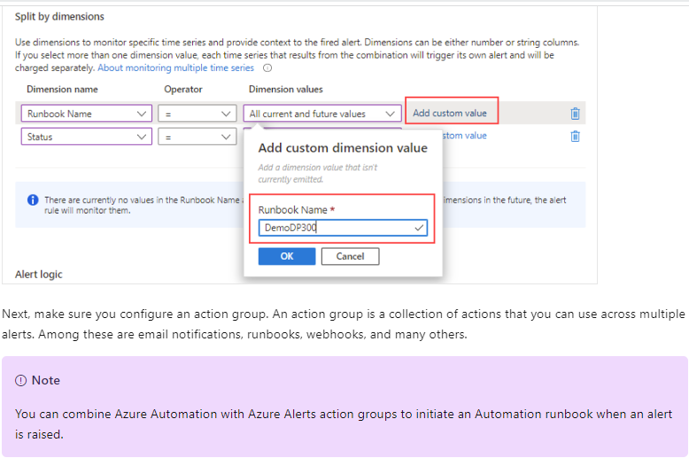

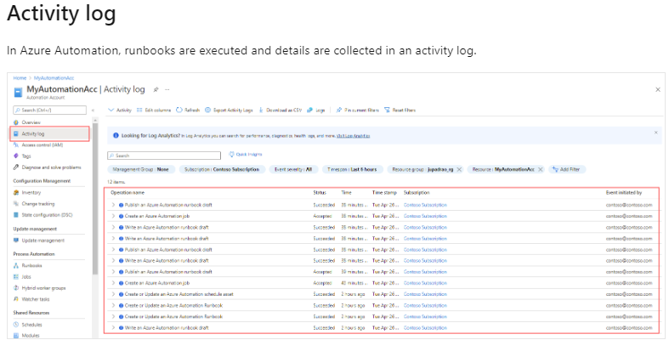

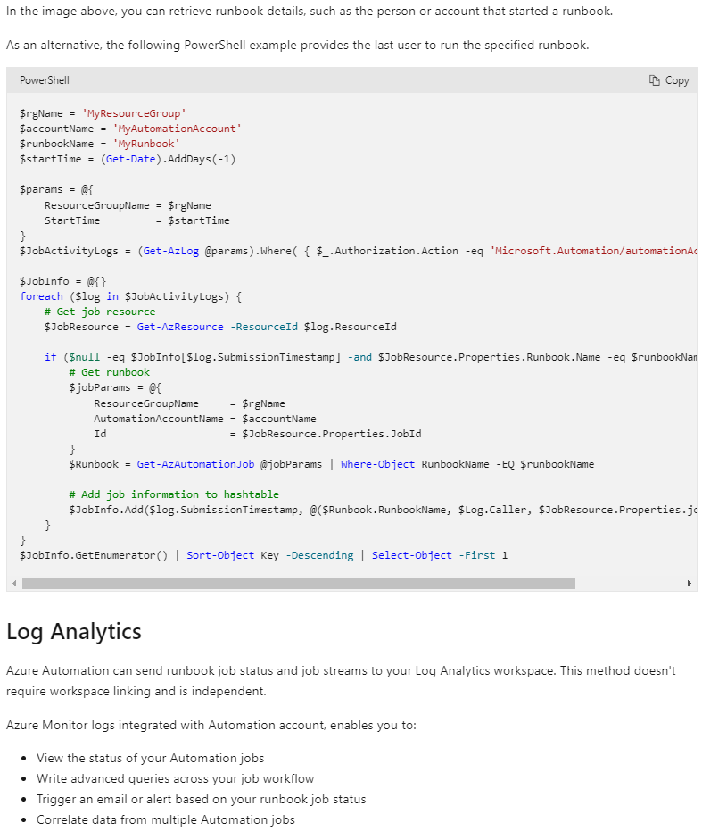

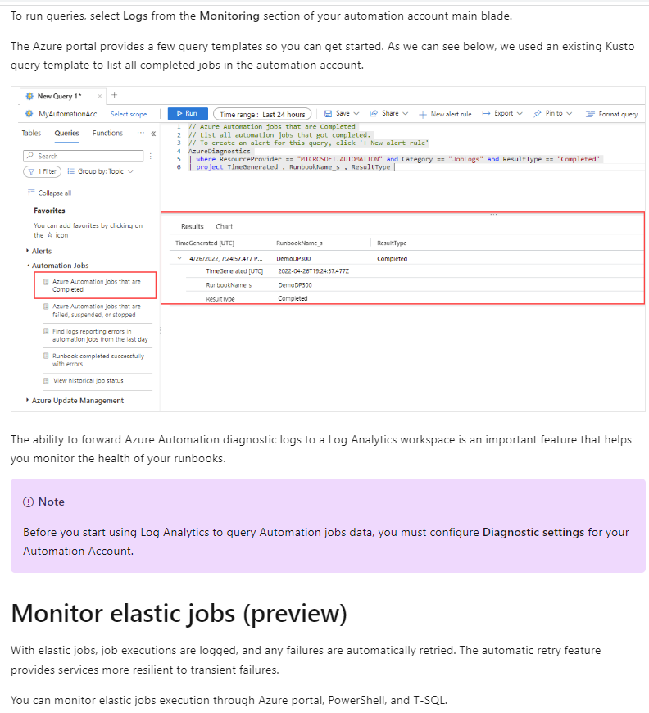

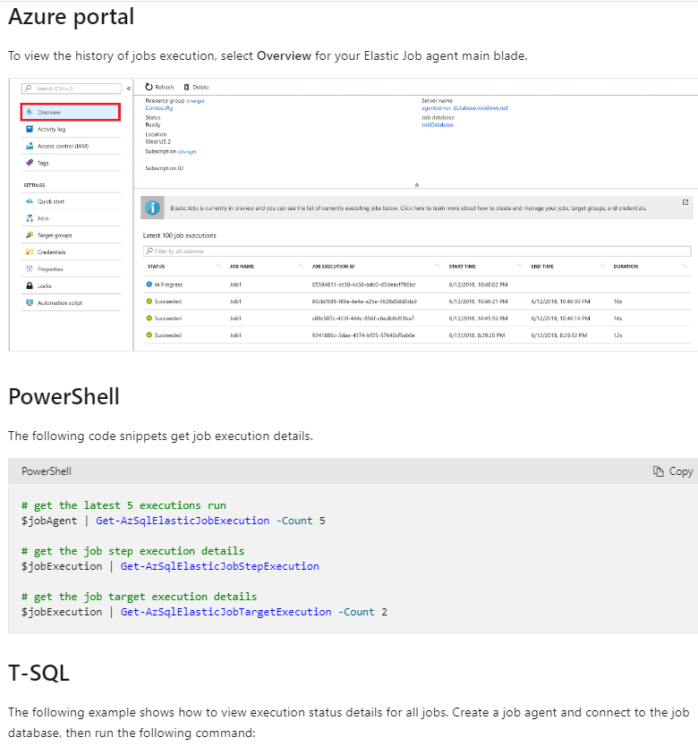

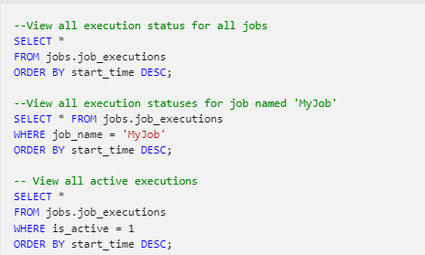

### U7. Knowledge check

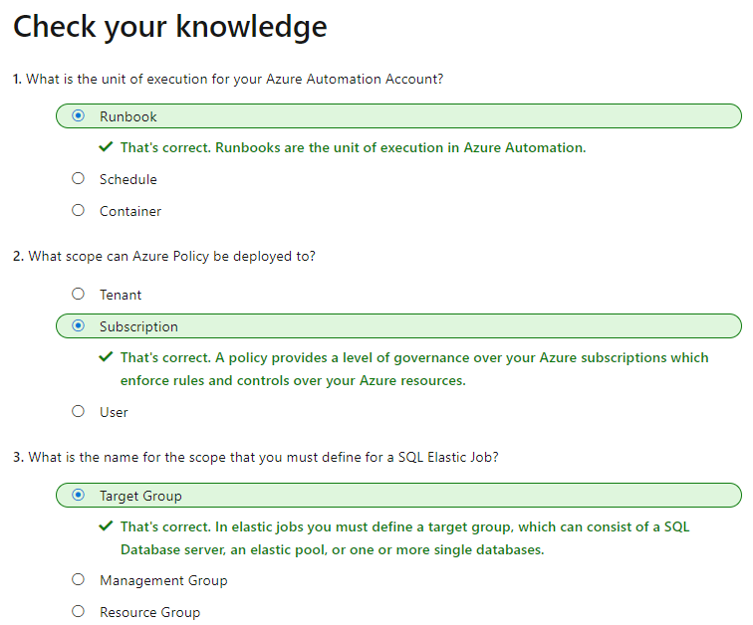

# LP7. Plan and implement a high availability and disaster recovery environment

## M1. Describe high availability and disaster recovery strategies

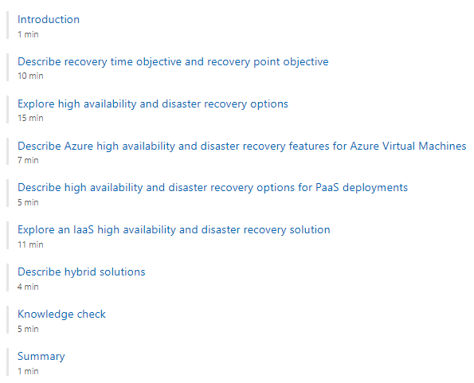

### U1. Introduction

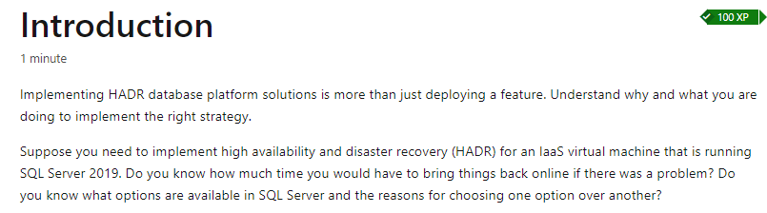

### U2. Describe recovery time objective and recovery point objective

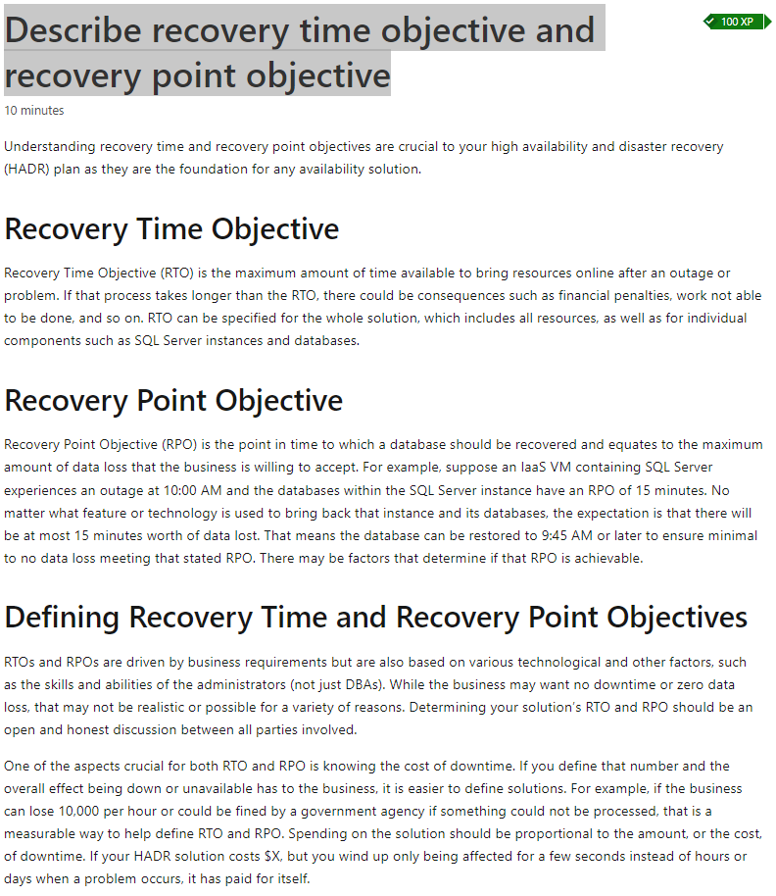

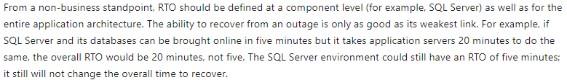

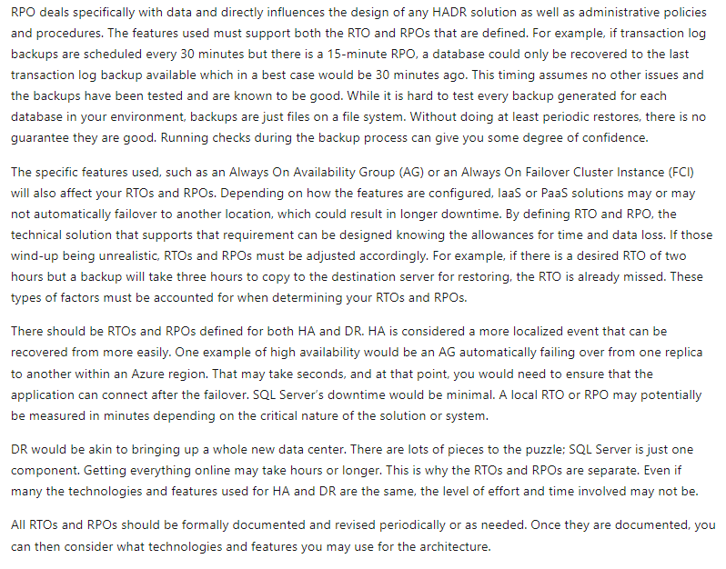

### U3. Explore high availability and disaster recovery options

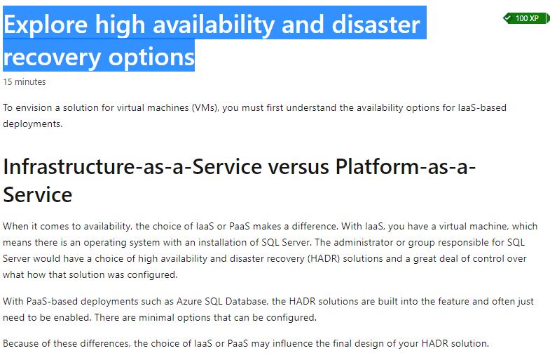

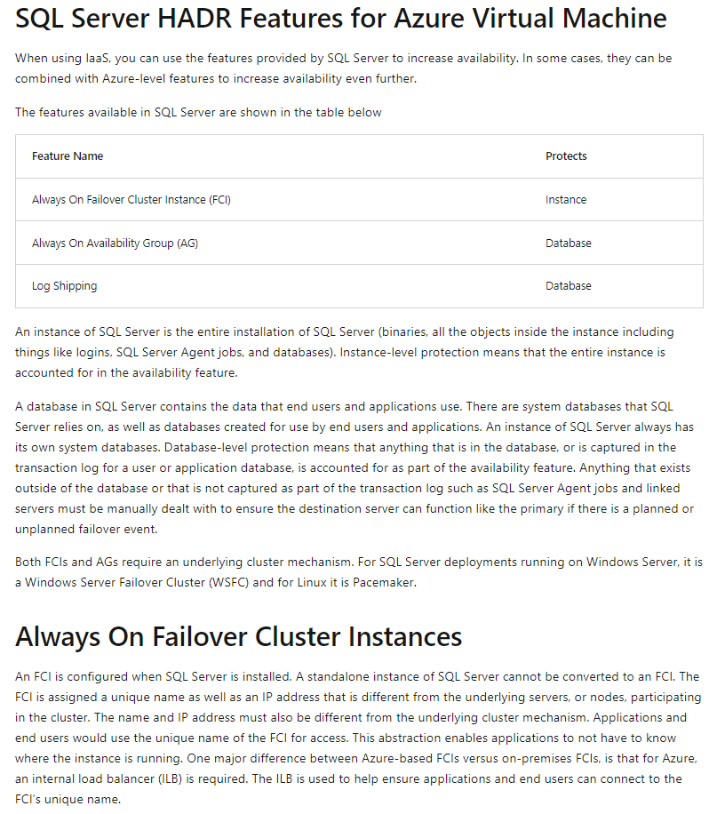

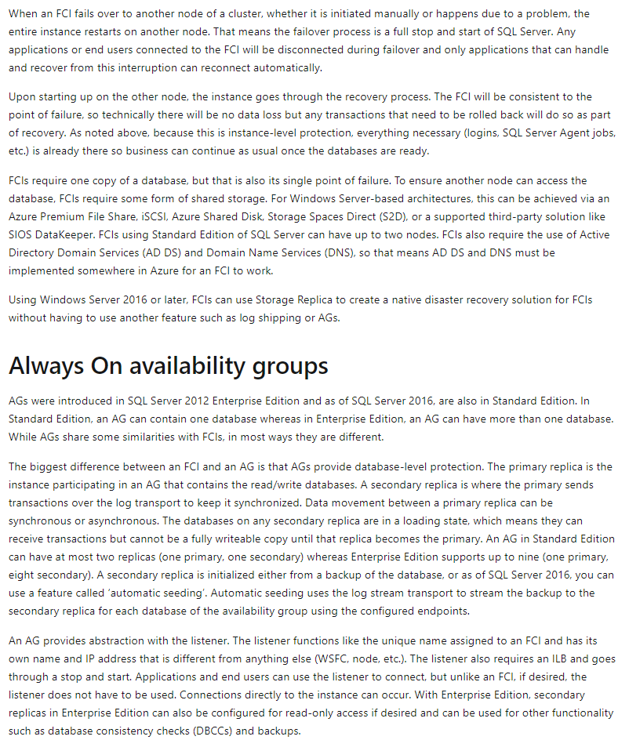

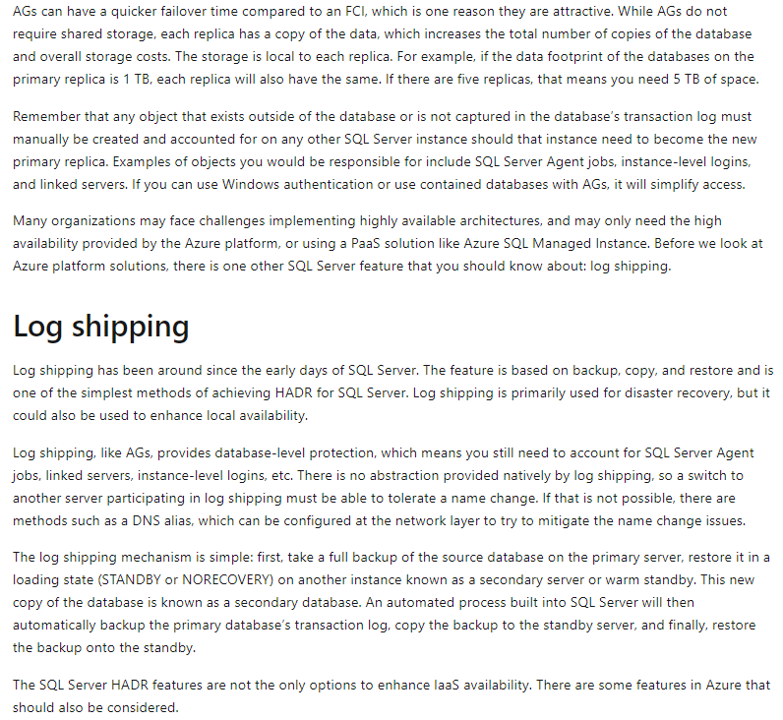

### U4. Describe Azure high availability and disaster recovery features for Azure Virtual Machines

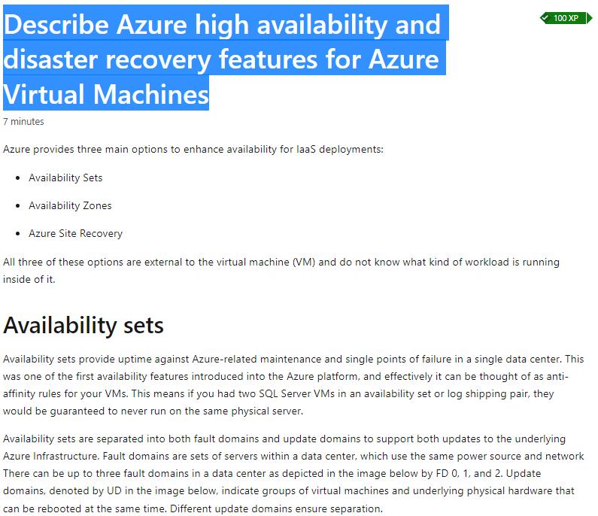

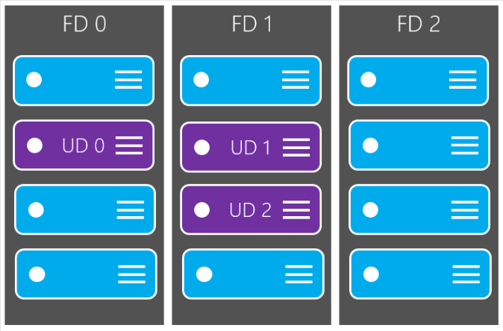

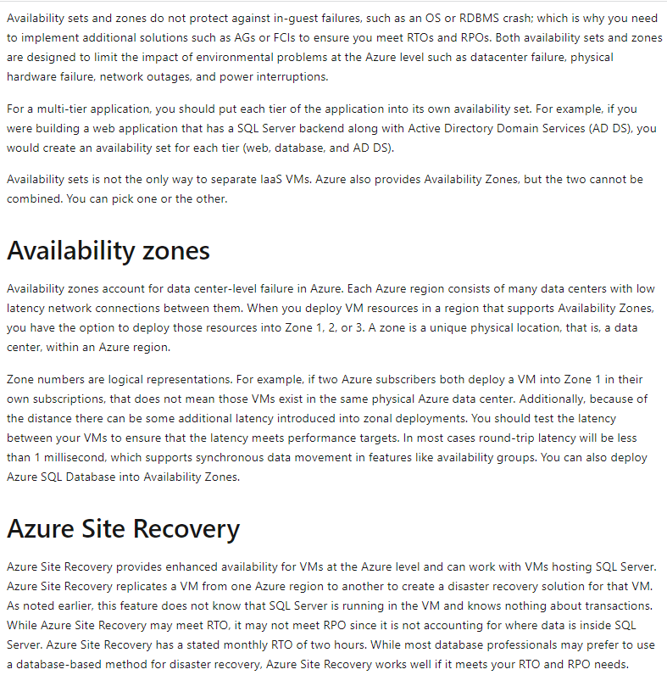

### U5. Describe high availability and disaster recovery options for PaaS deployments

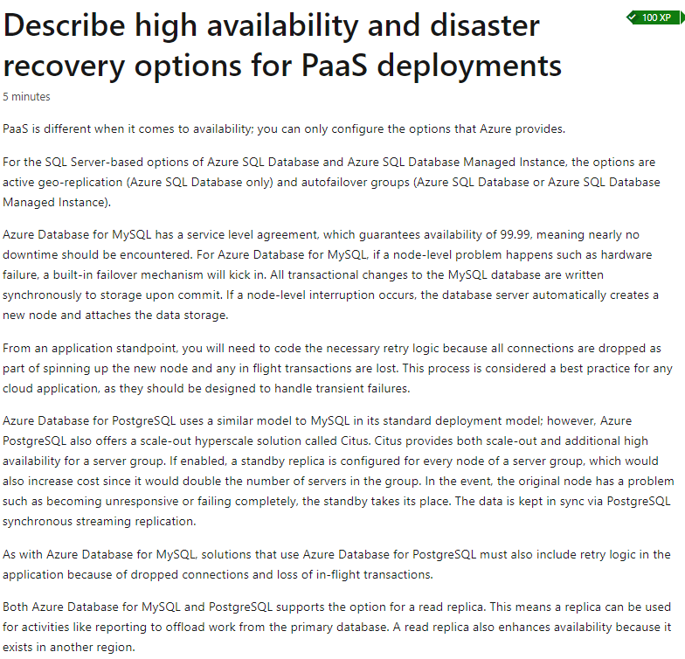

### U6. Explore an IaaS high availability and disaster recovery solution

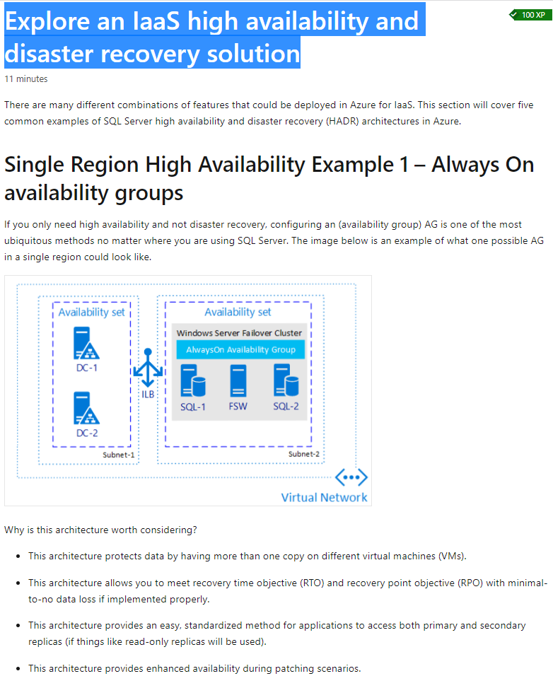



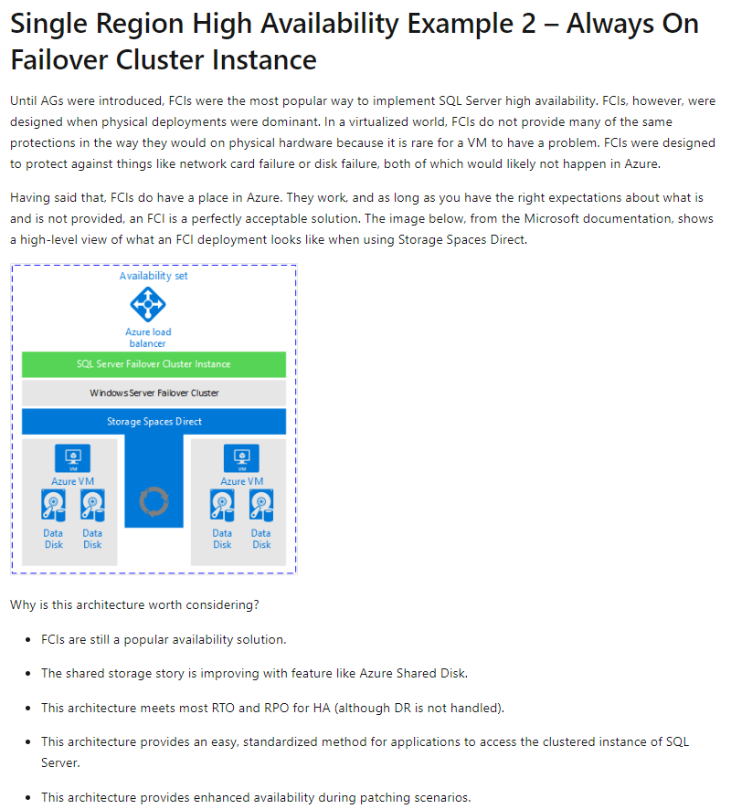

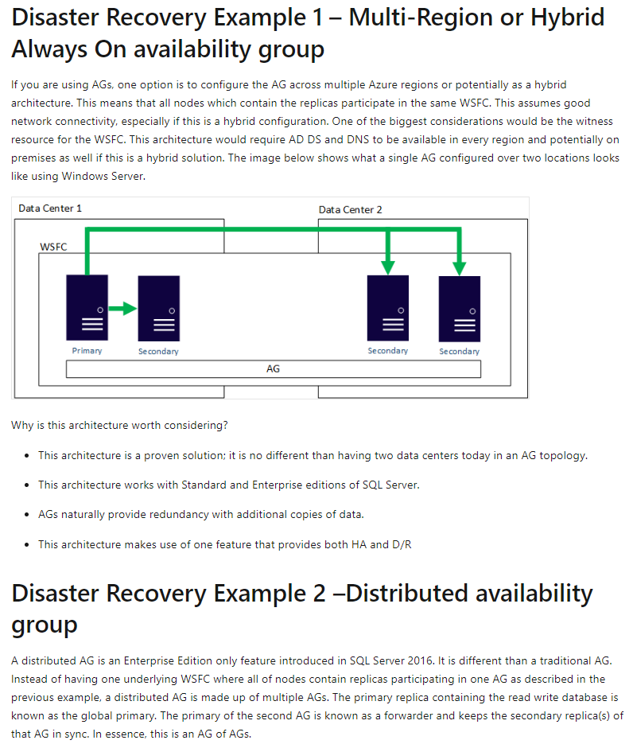

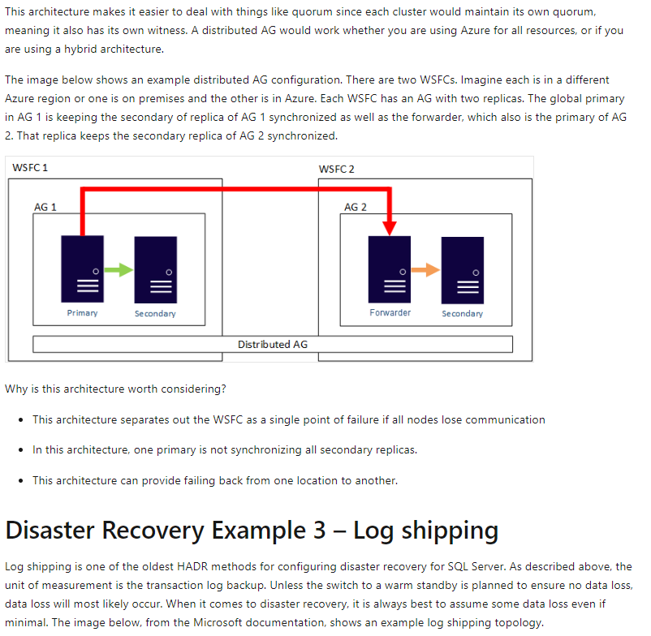

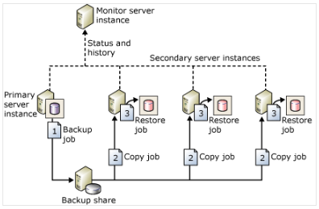

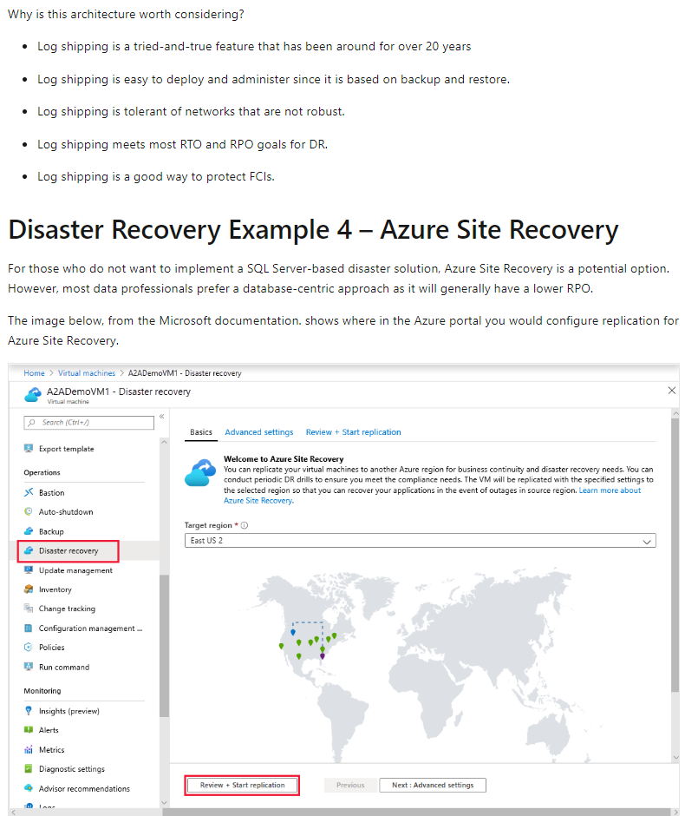

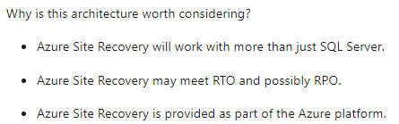

### U7. Describe hybrid solutions

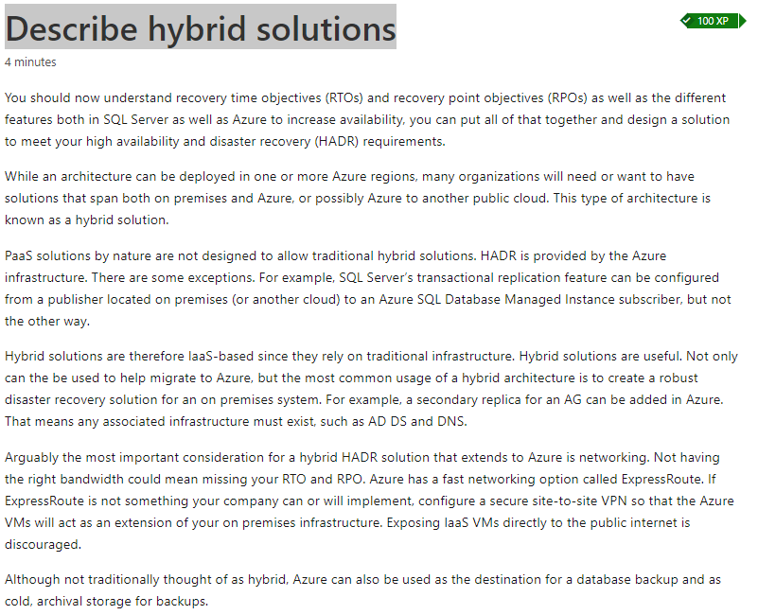

### U8. Knowledge check

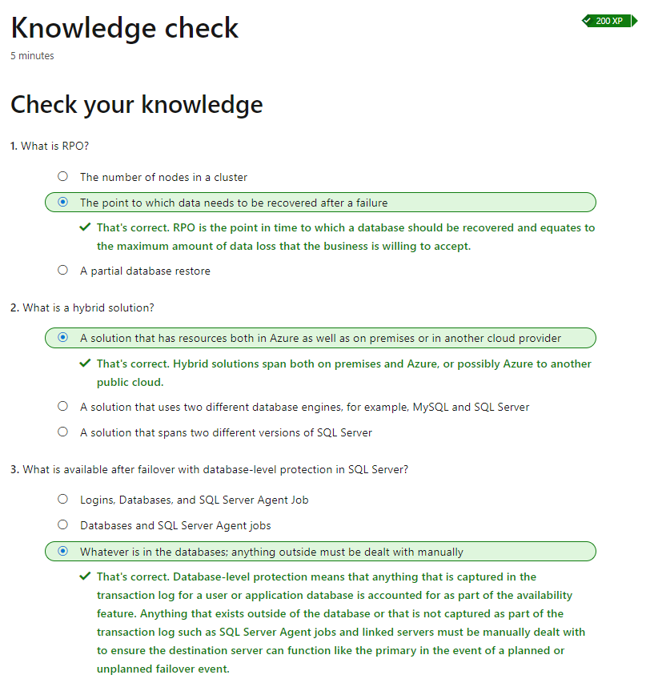

## M2. Explore IaaS and PaaS solutions for high availability and disaster recovery

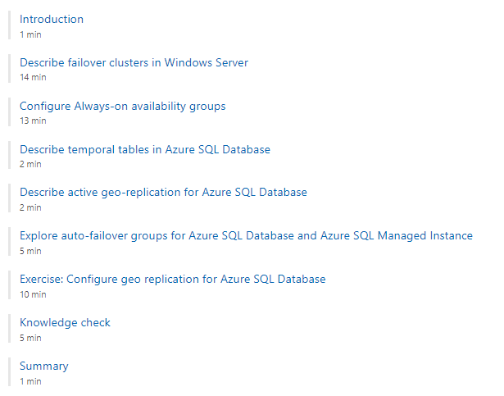

### U1. Introduction

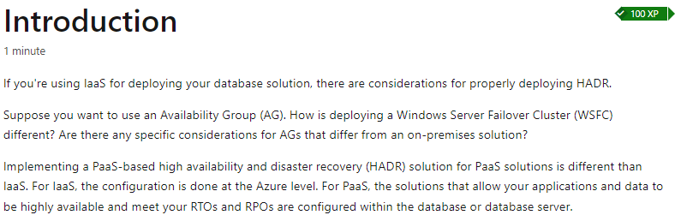

### U2. Describe failover clusters in Windows Server

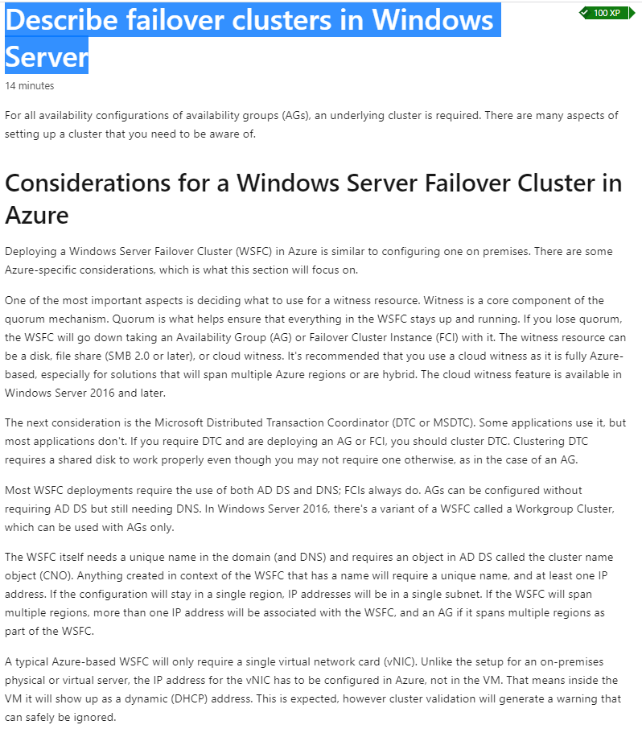

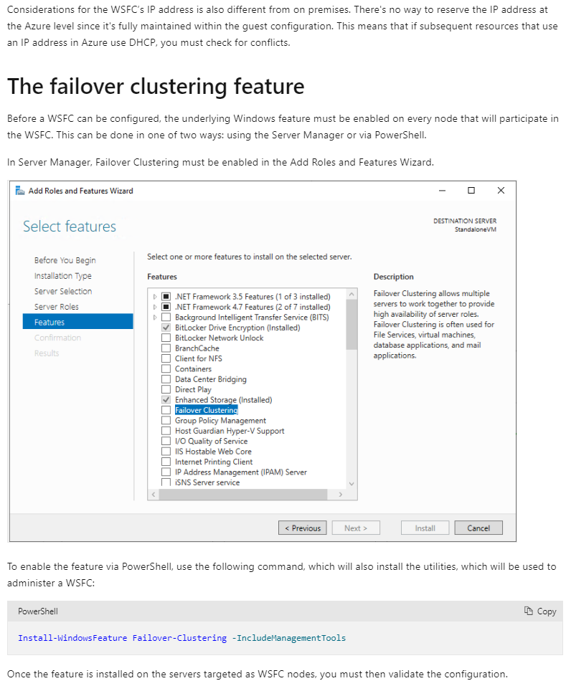

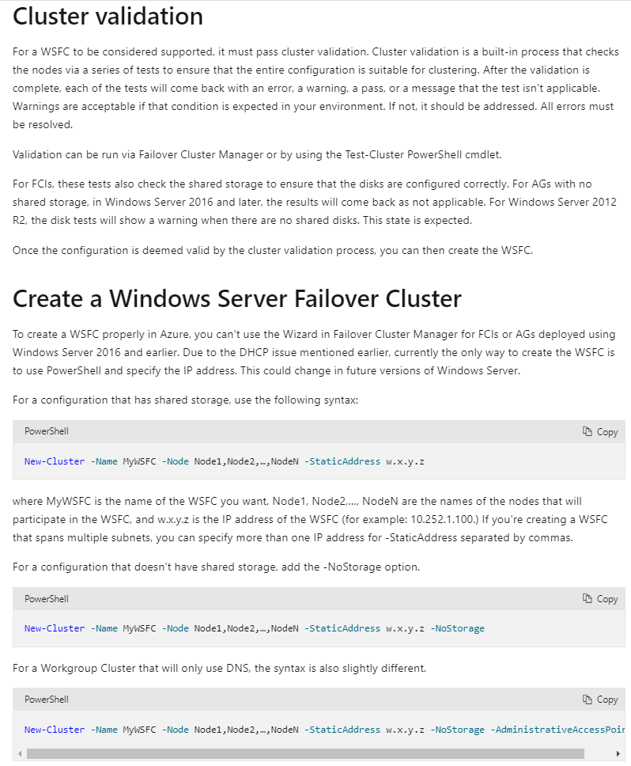

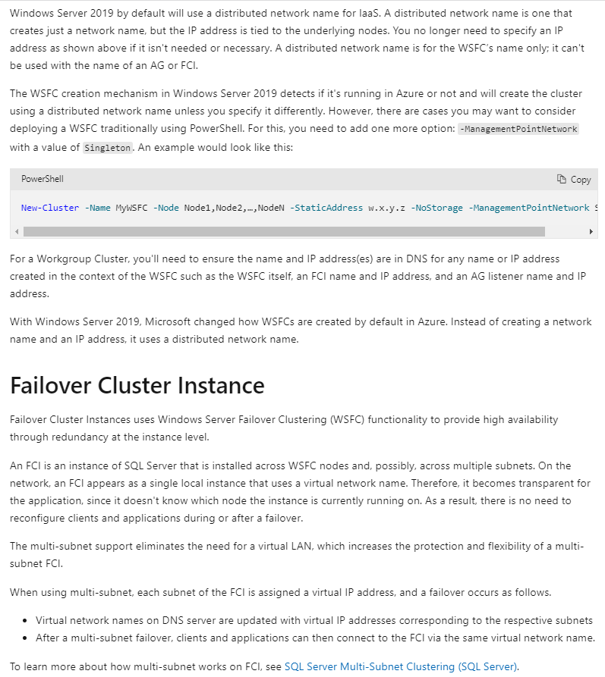

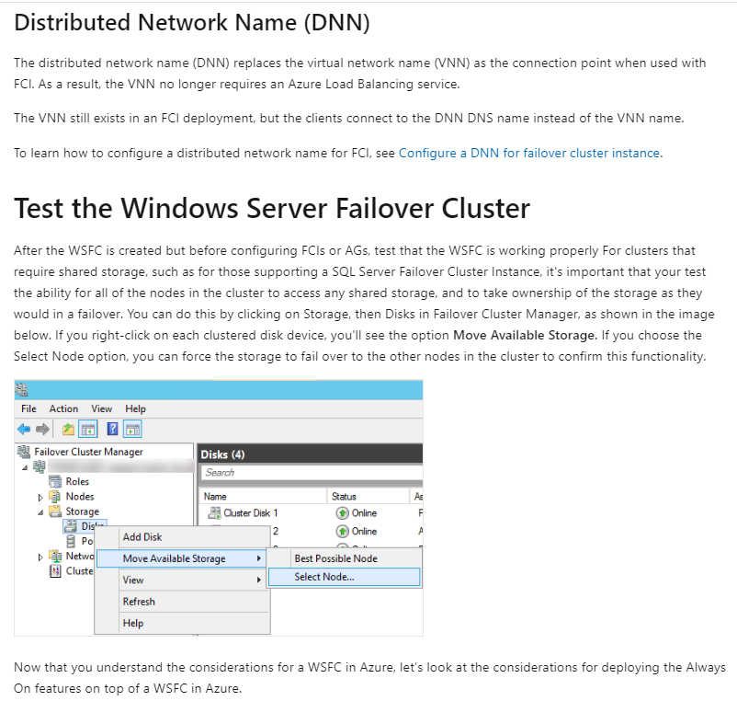

### U3. Configure Always-on availability groups

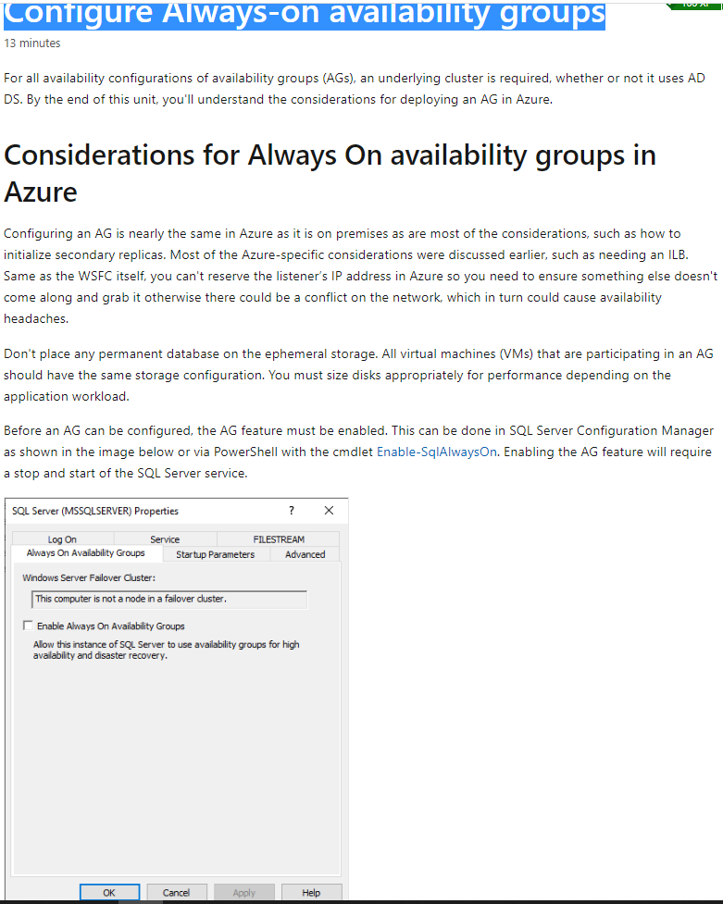

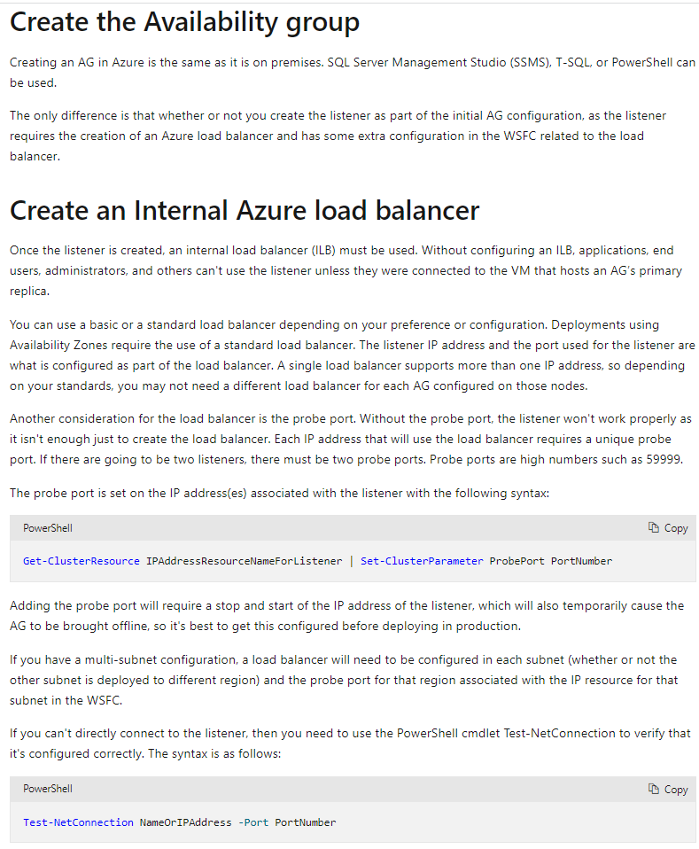

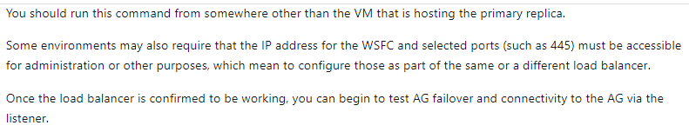

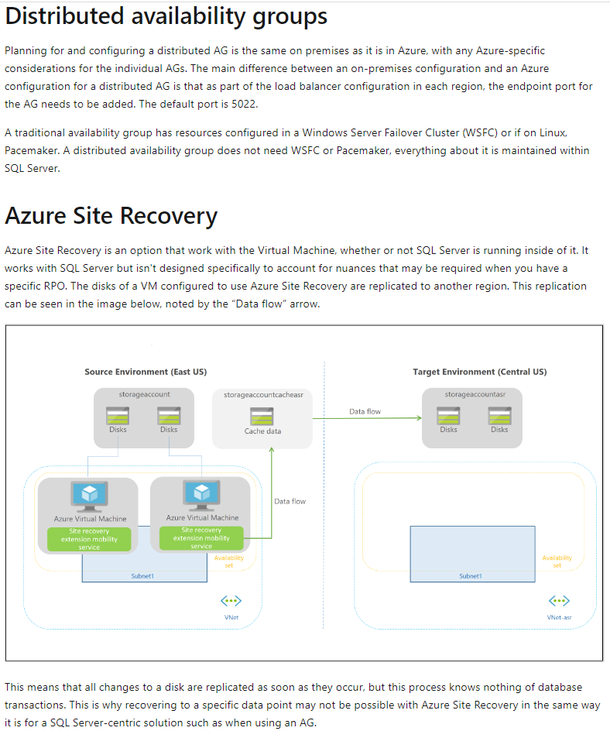

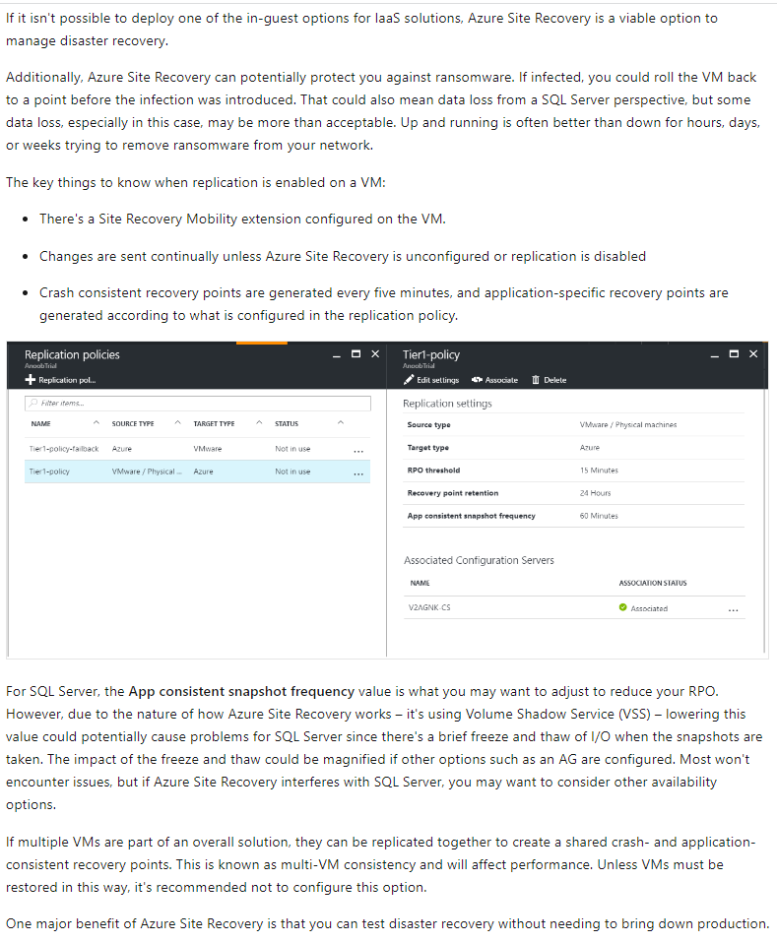



### U4. Describe temporal tables in Azure SQL Database

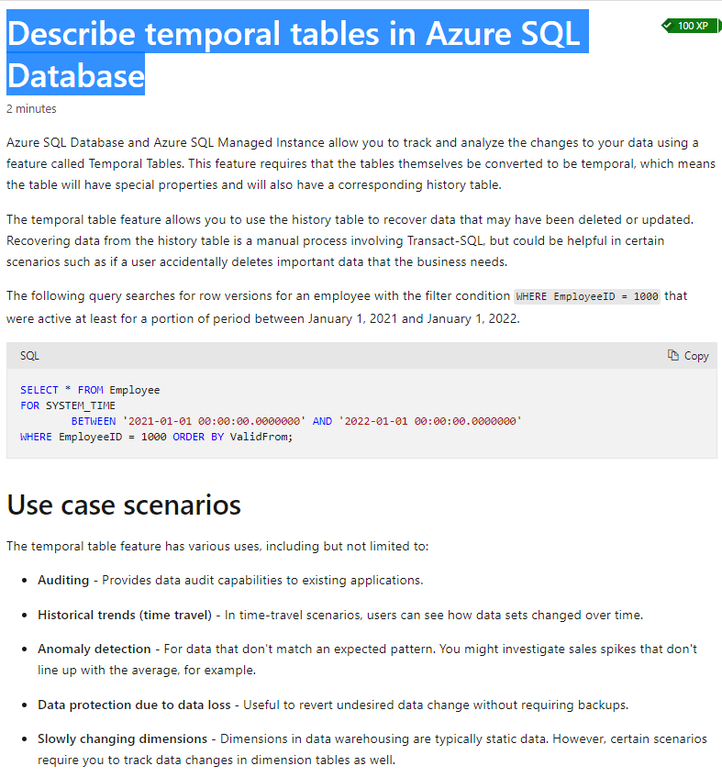

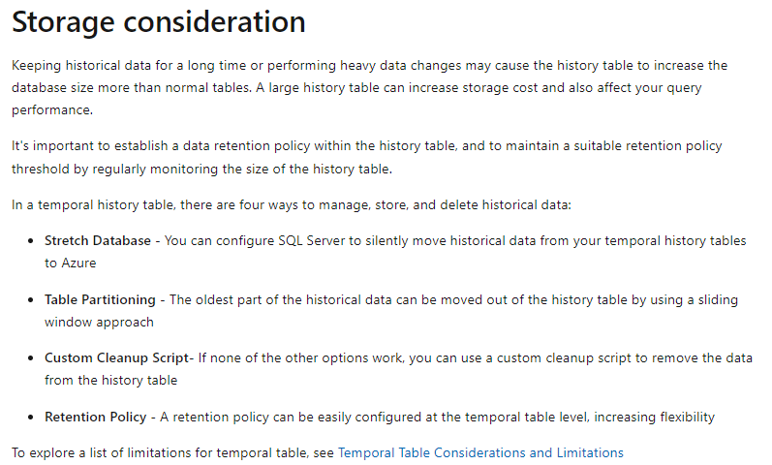

### U5. Describe active geo-replication for Azure SQL Database

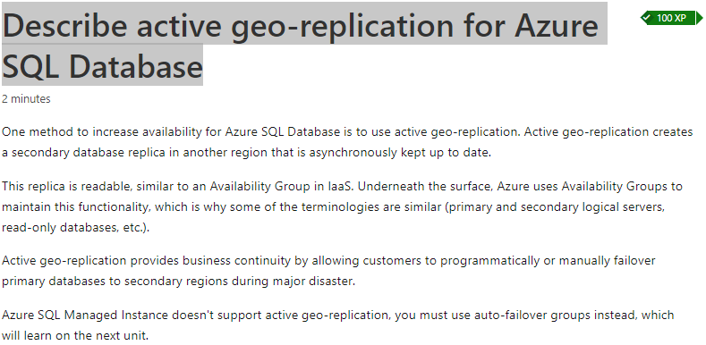

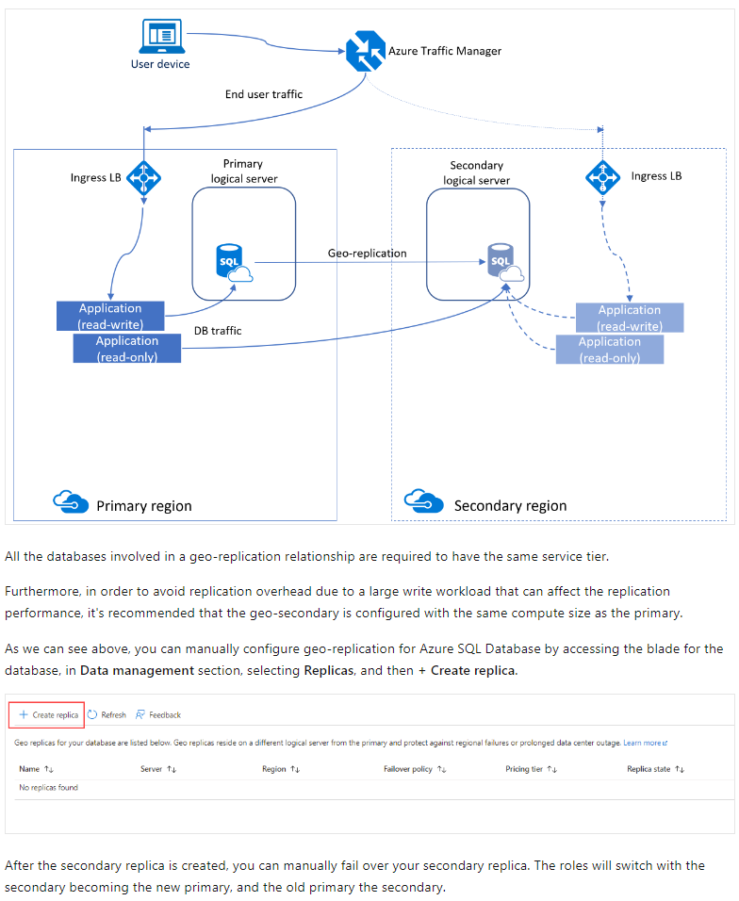

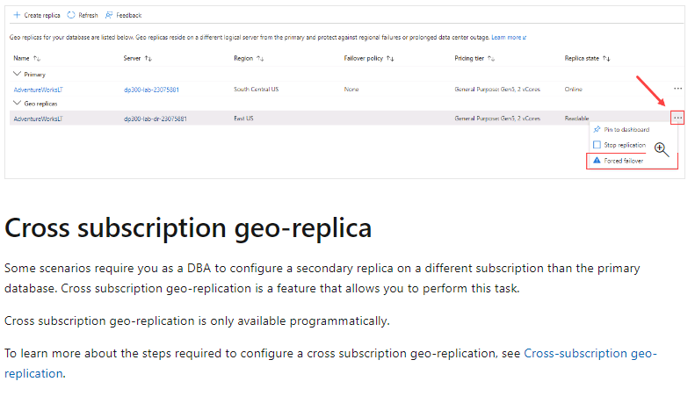

### U6. Explore auto-failover groups for Azure SQL Database and Azure SQL Managed Instance

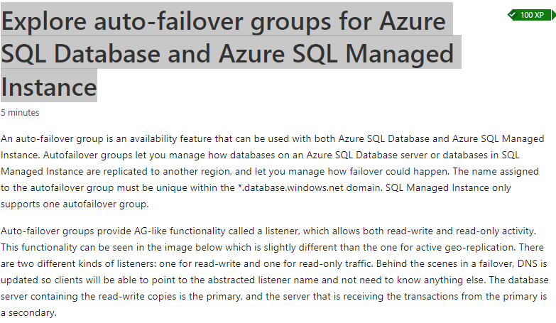

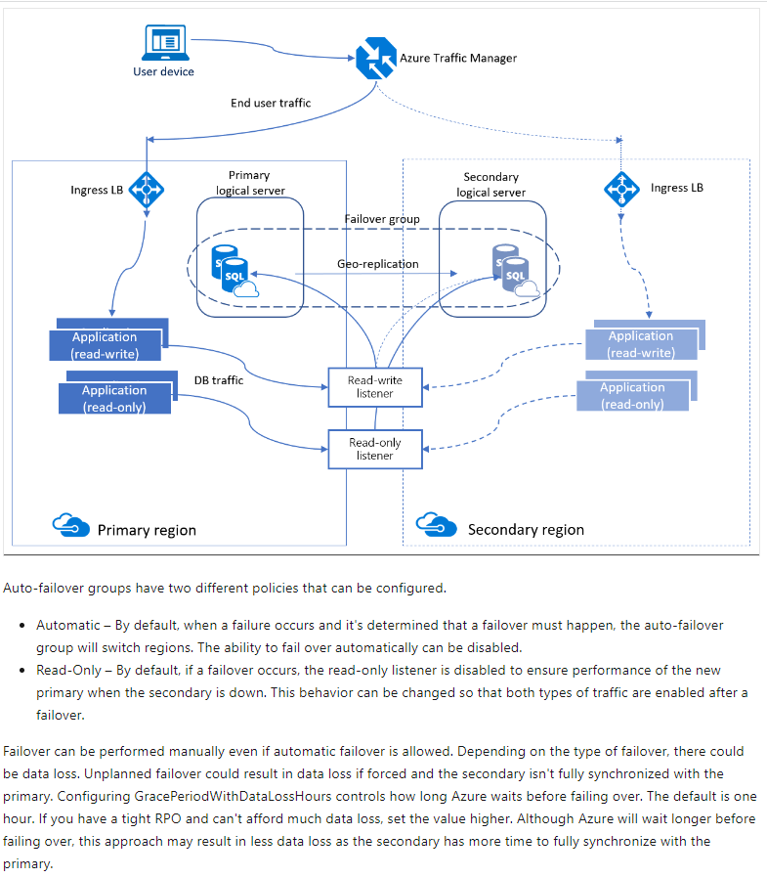

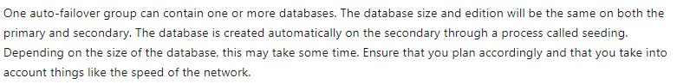

### U7. Knowledge check

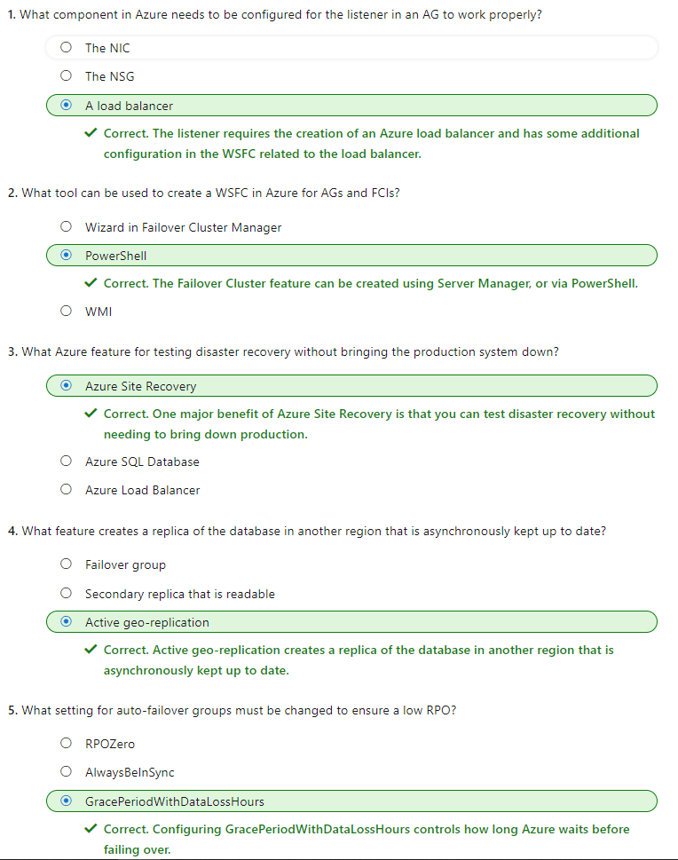

## M3. Back up and restore databases

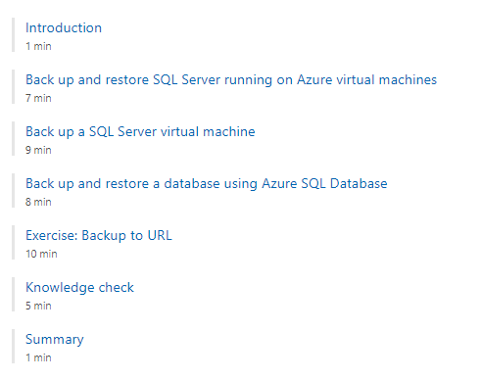

### U1. Introduction

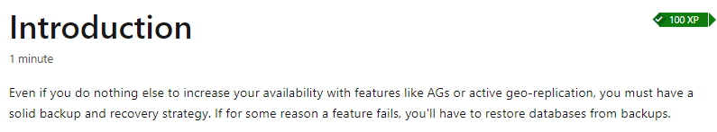

### U2. Back up and restore SQL Server running on Azure virtual machines

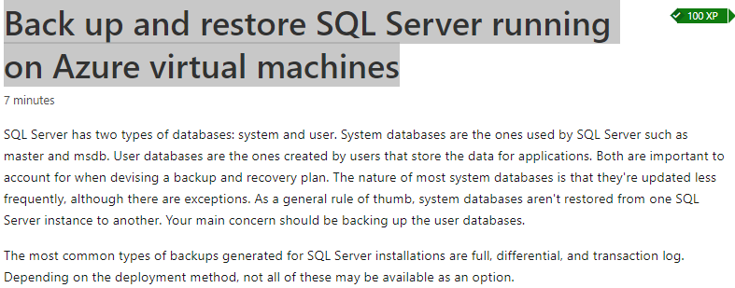

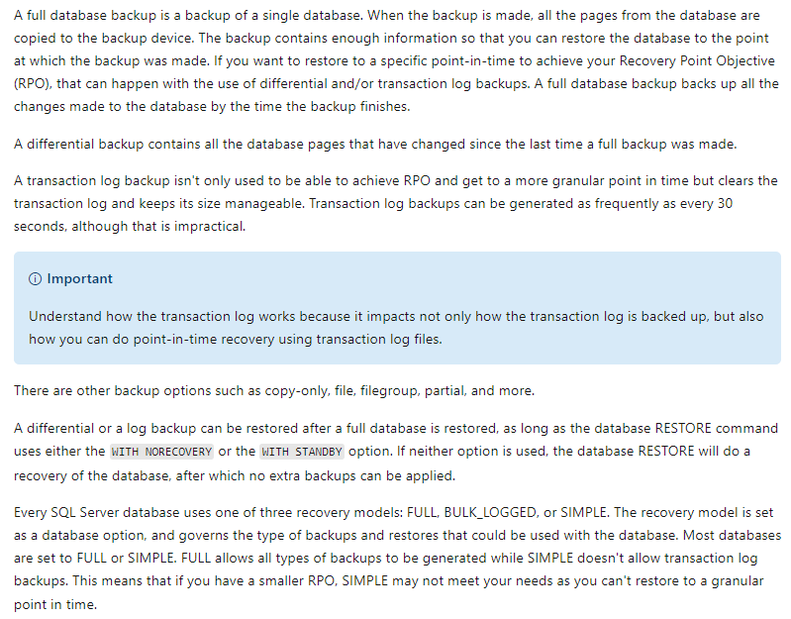

### U3. Back up a SQL Server virtual machine

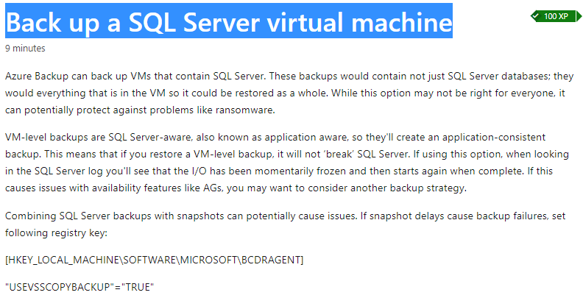

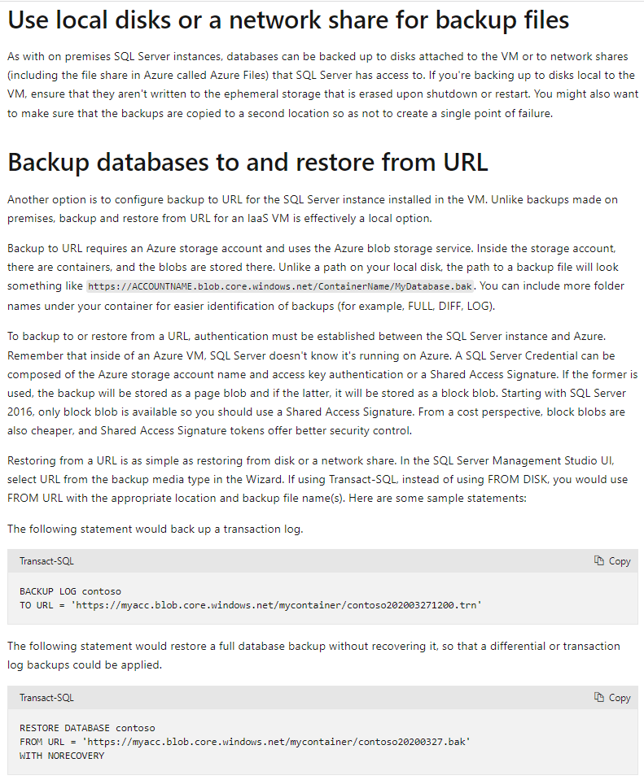

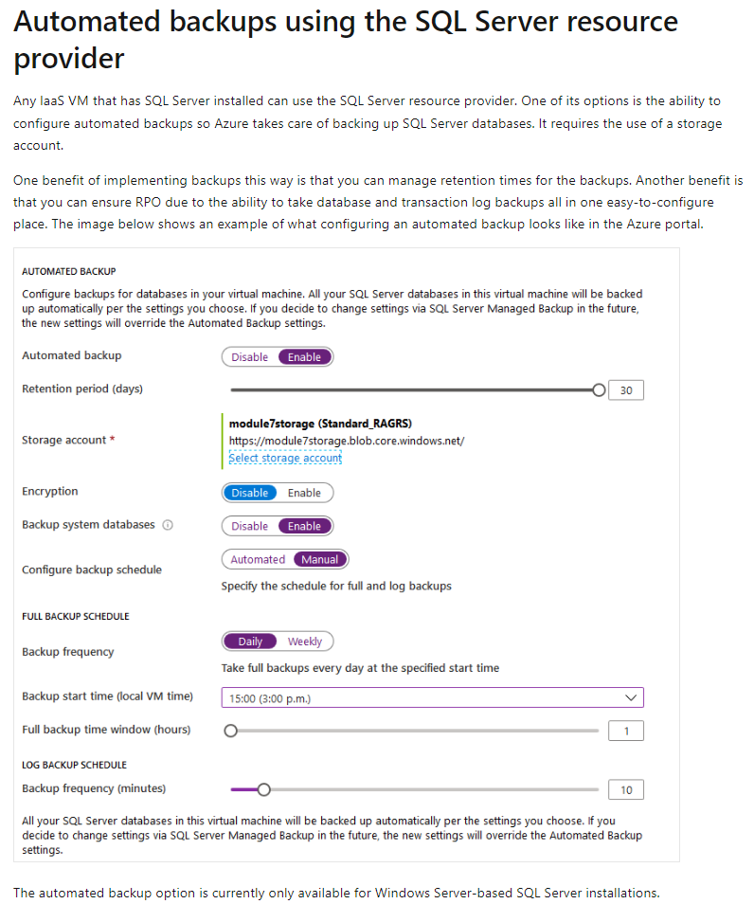

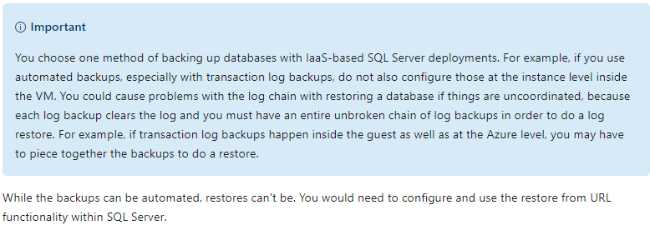

### U4. Back up and restore a database using Azure SQL Database

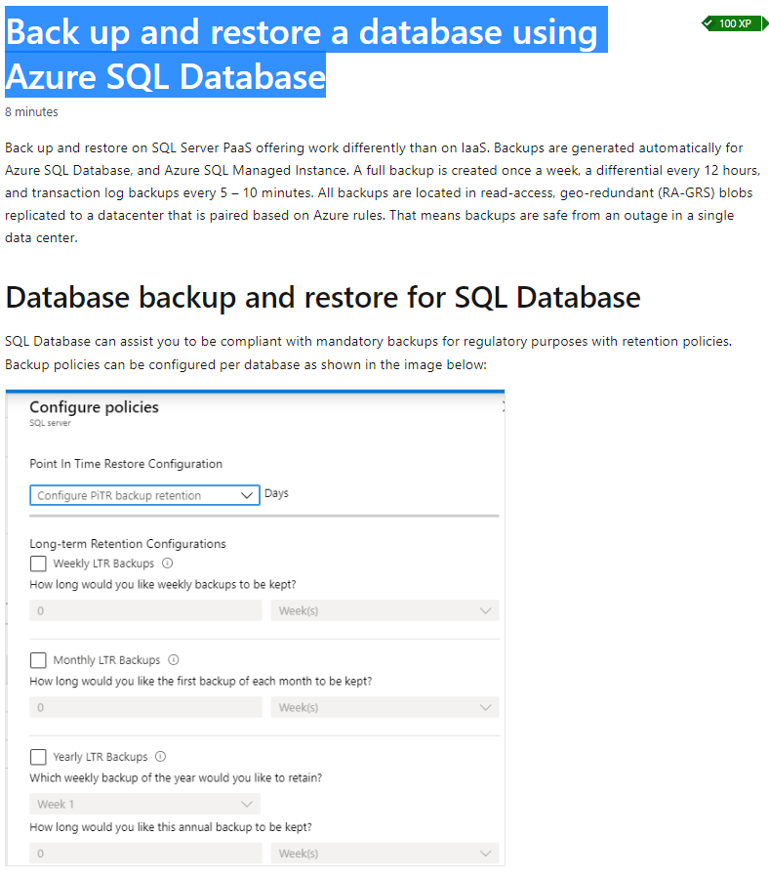

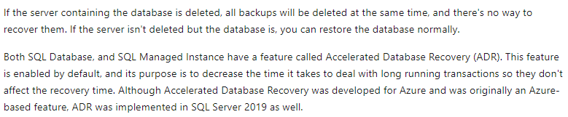

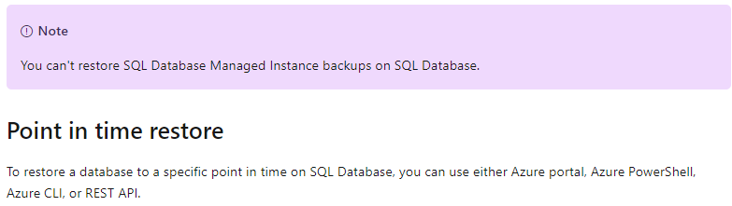

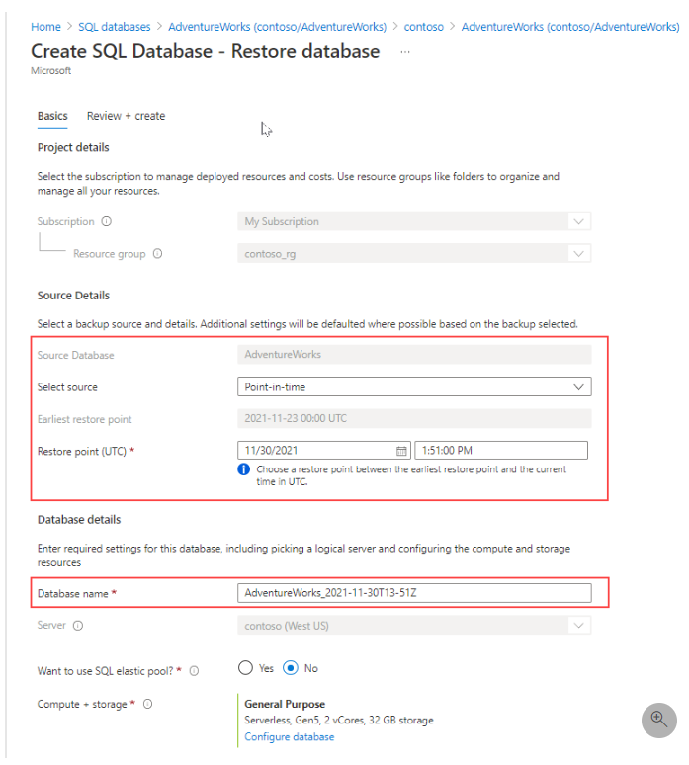

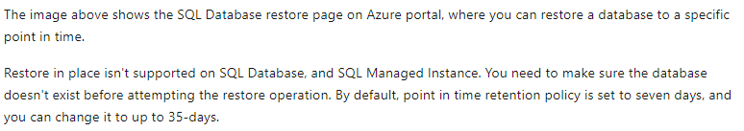

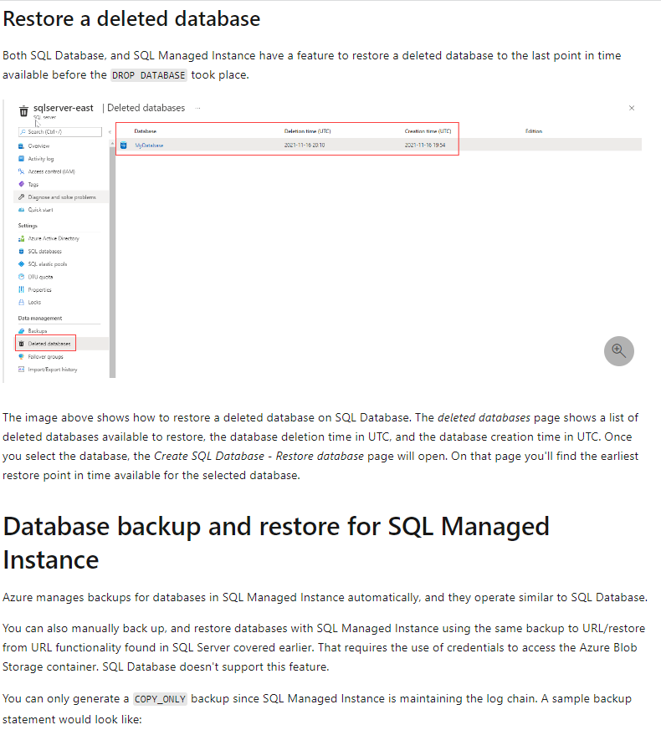

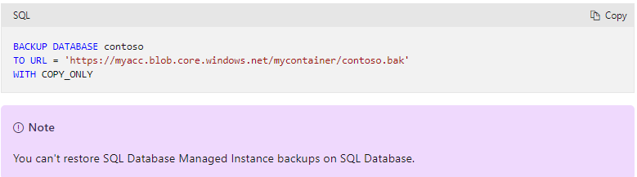

### U5. Knowledge check

